1.

weed(但是对比效果不好，只比rtdetr-l好，比yolov8\v7的差)

|  |  |  |  |  |  |  |  |
| --- | --- | --- | --- | --- | --- | --- | --- |
| **method** | **size** | **P** | **Q** | **AP50** | **mAP** | **Para** | **GFLOPS** |
| RTYO | 640 | 86.6 | 79.9 | 84.7 | 63 | 3767Wpara | 142.9 |
| RTYO+loss | 640 | 87.2 | 79.1 | 84.3 | 63.3 | 3767Wpara | 142.9 |
| RTYO+CFB | 640 | 86.8 | 79.3 | 84.2 | 62.9 | 3767Wpara | 142.9 |
| RTYO+LFPN | 640 | 87.5 | 80.2 | 84.7 | 63.6 | 3814W | 143.2 |
| ours | 640 | **88.8** | 78.7 | **84.9** | 63.2 | 3814W | 143.2 |

v8

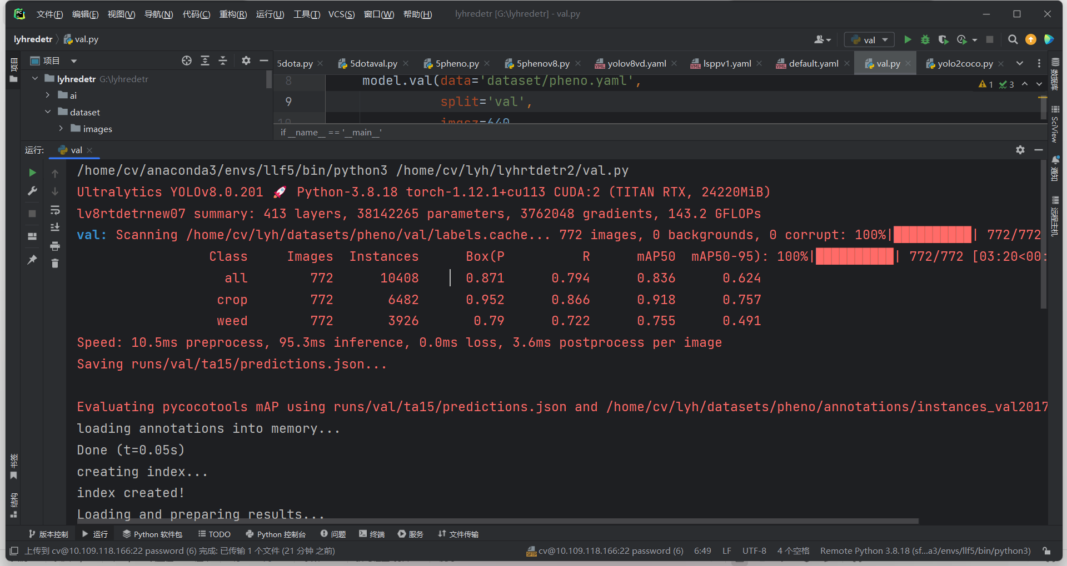

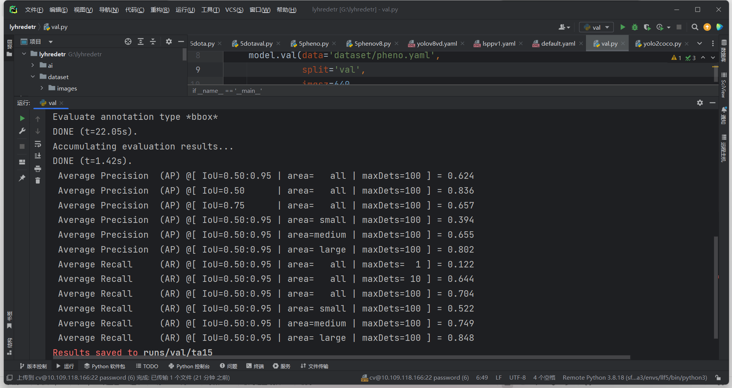

|  |  |  |  |  |  |  |  |
| --- | --- | --- | --- | --- | --- | --- | --- |
| **method** | **size** | **P** | **Q** | **AP50** | **mAP** | **Para** | **GFLOPS** |
| v3 |  | 86 | 80 | 85.9 | 67 | 3767Wpara | 142.9 |
| v5 |  | 87.6 | 81.2 | 87.1 | 68.6 | 3767Wpara | 142.9 |
| r-l |  | 87.7 | 79.2 | 84.4 | 62.6 | 3767Wpara | 142.9 |
| v8 |  | 88.3 | 79.9 | 86.7 | 68.6 | 3814W | 143.2 |
| ours |  | **88.8** | 79.9 | **84.9** | 63.2 | 3814W | 143.2 |
|  |  |  |  |  |  |  |  |
|  |  |  |  |  |  |  |  |

1.

​​Dear Editors,

Sorry for disturbing you. First of all, thank you very much for your work and consideration in the publication of our paper (Manuscript Number: Access-2024-10129​). On behalf of our team, we would like to express our sincere gratitude to the editors and reviewers. Our manuscript YH-RTYO:An End-to-End Object Detection Method for Crop Growth Conditions in UAV Scenarios [Manuscript Number: Access-2024-10129] has been in submission production status for one and a half months. The status of Submissions in Production has been going on for one and a half months. l would be grateful if you could let me know whether there has been any further progress on my submission. We greatly appreciate the efficient, professional, and rapid processing of our paper by your team. We would like to know how soon we can expect to receive an acceptance letter for our manuscript from you.

Best regards!

Yours sincerely,

Yihang Li

Corresponding author:

Name: Wenzhong Yang

E-mail address: [yangwenzhong@xju.edu.cn](mailto:yangwenzhong@xju.edu.cn)

Query:Access-2024-10129

04 rtdetr-yolov8s-lpe

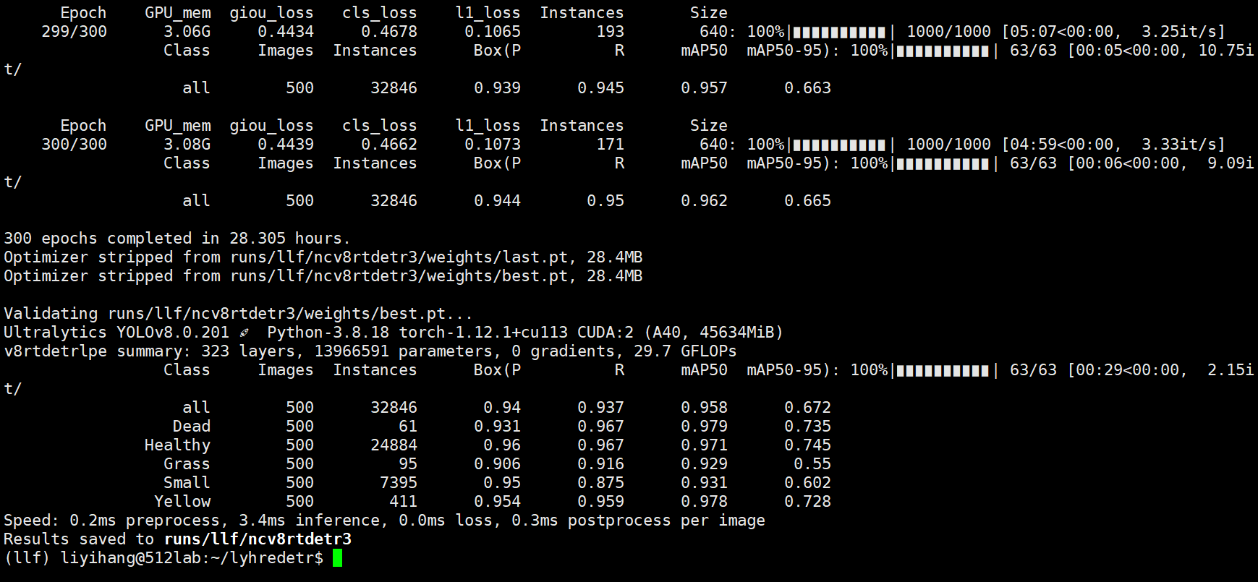

02 rtdetr-yolov8s

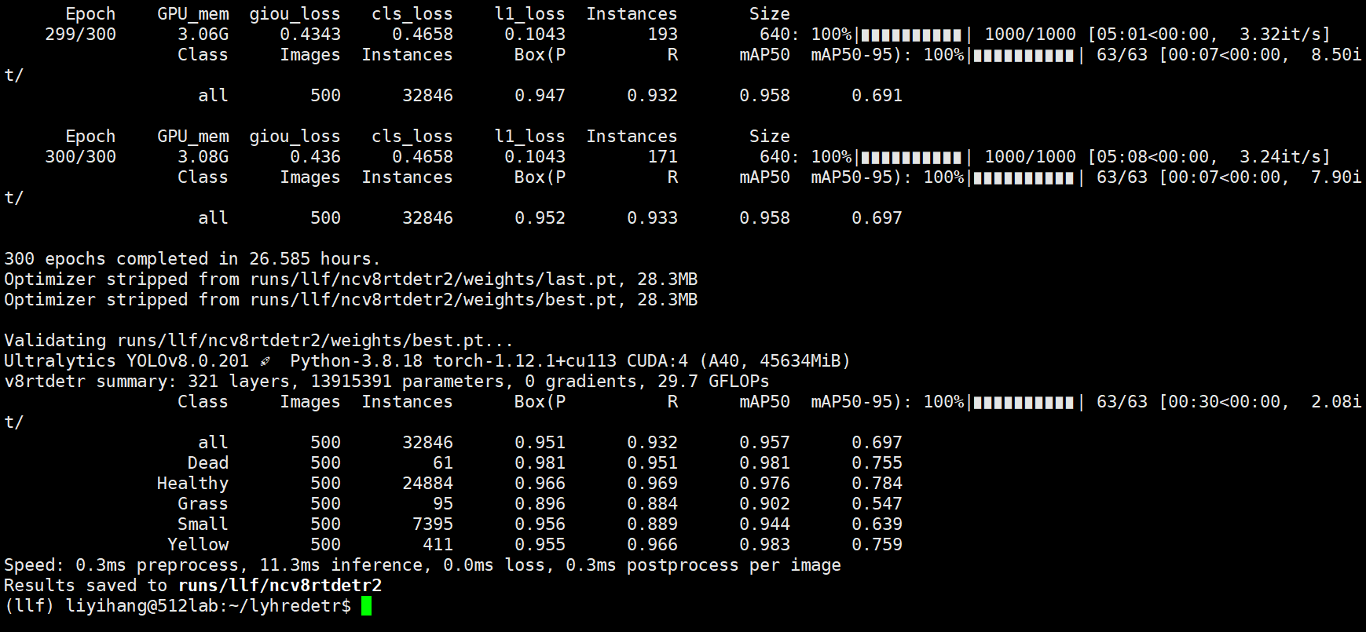

rtdetr-yolov8l-ECM 05

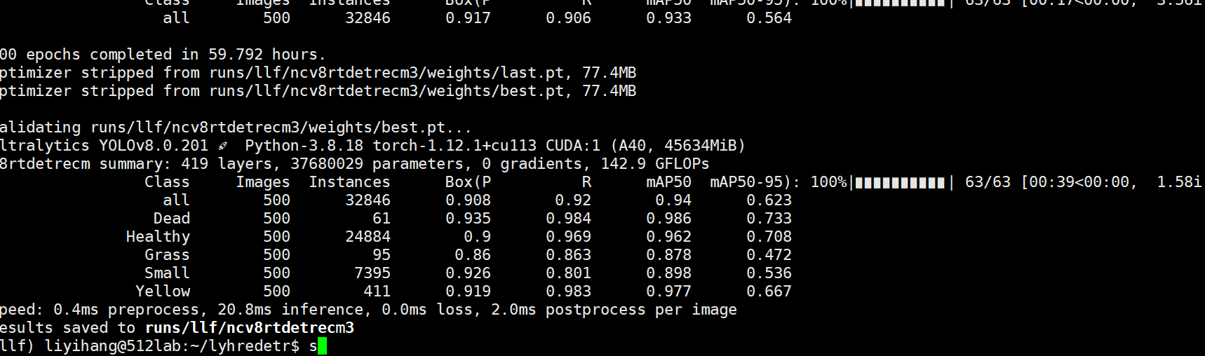

rtdetr v8l 06

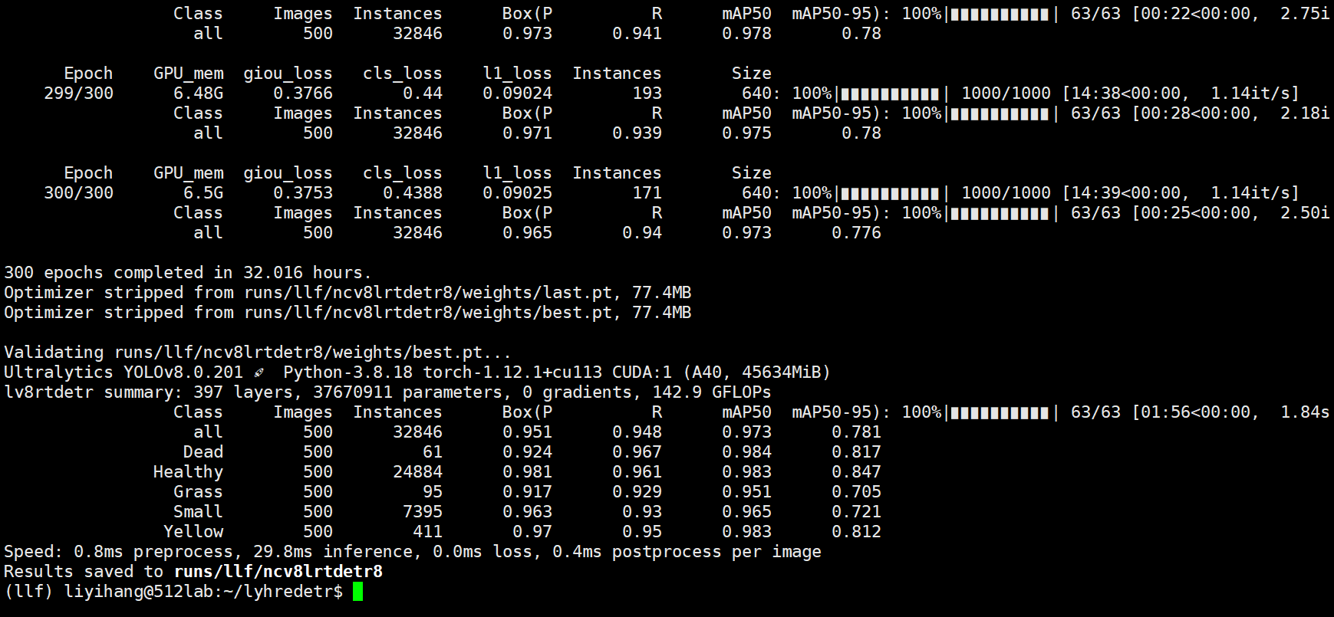

rtdetr v8l ecm(换到了小目标层连接的位置了) 07

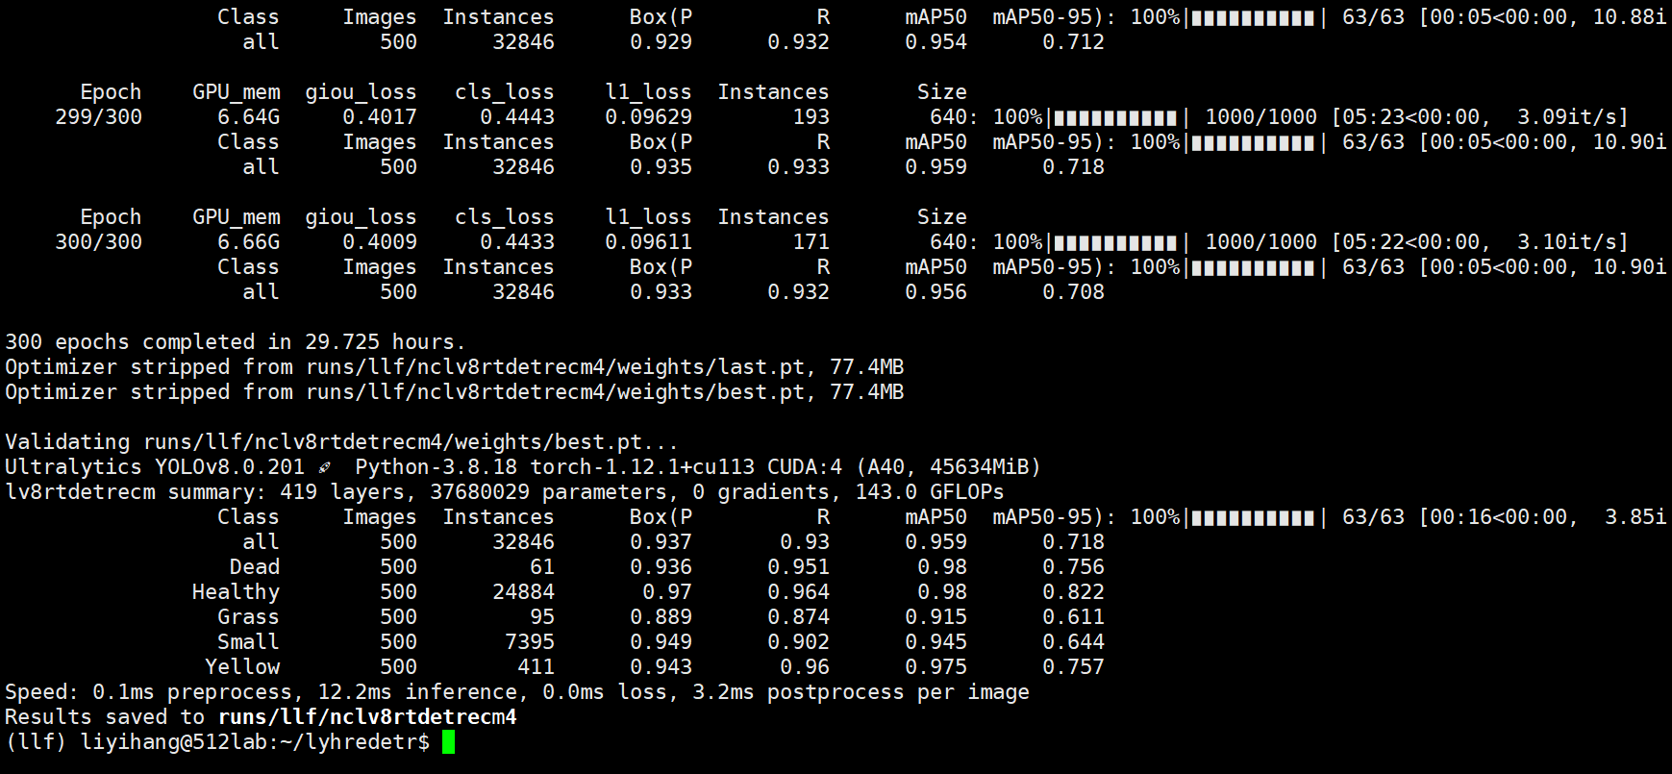

rtdetr v8l iou(inner) 08 这里面目前在10以后比原来高

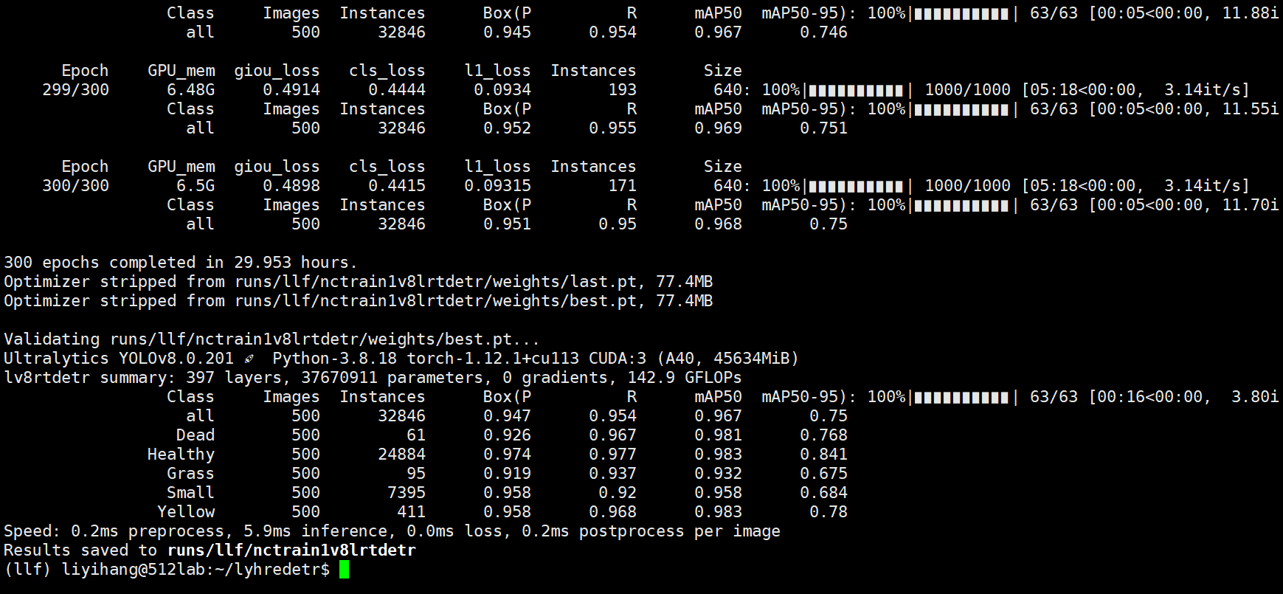

rtdetr v8l iou(ggg mpdiou) 09

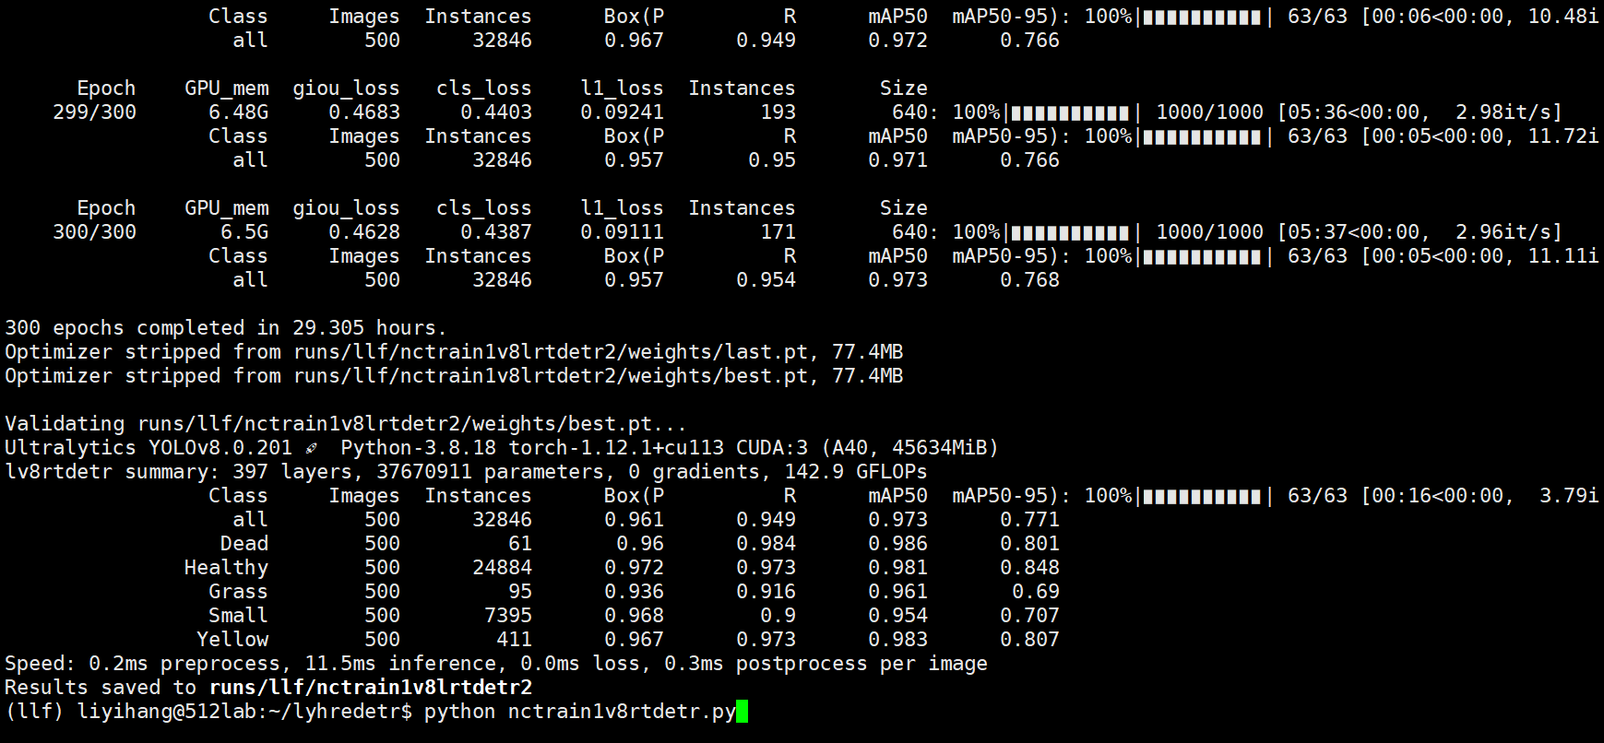

问一下：

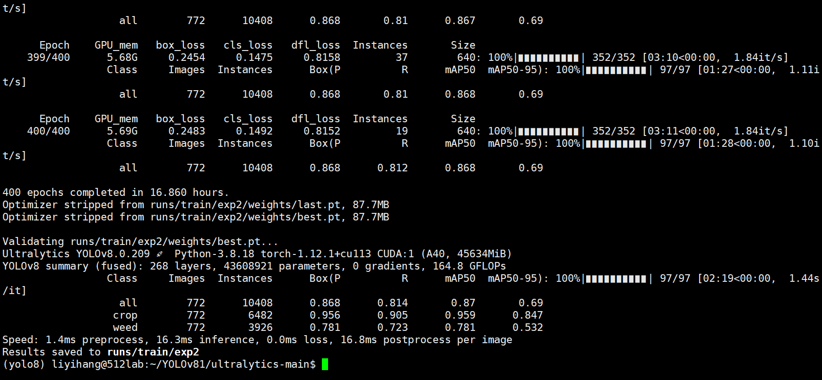

rtdetr v8l iou(mpdiou) 10

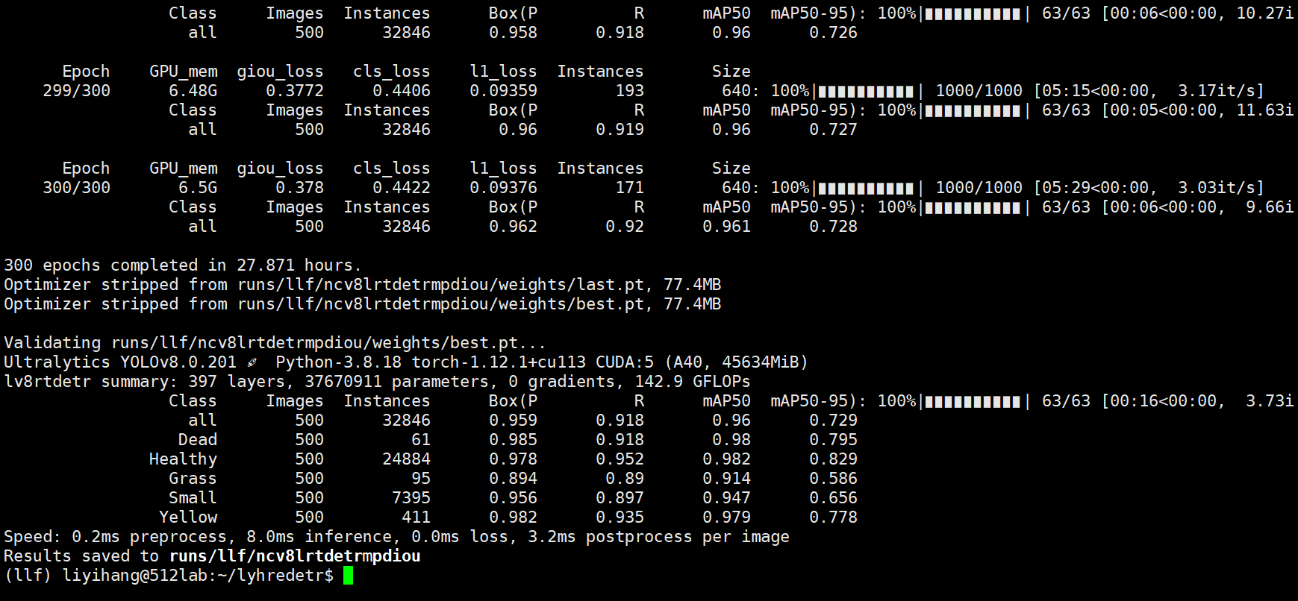

11 inner_eiou device=5

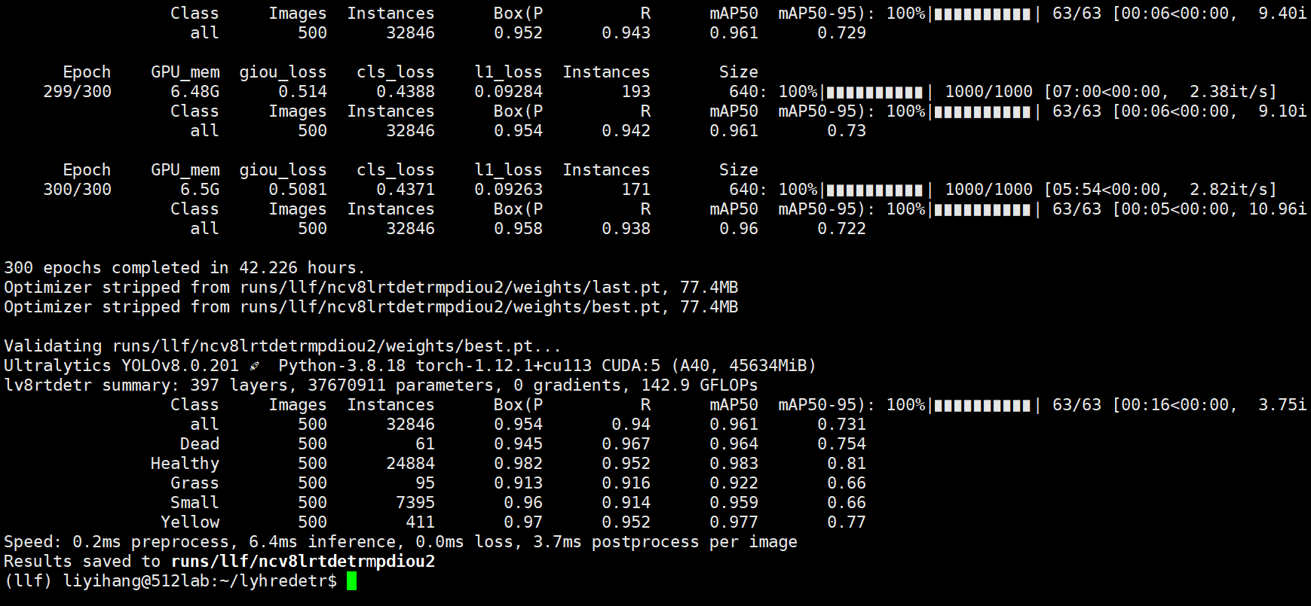

12 eiou device=4

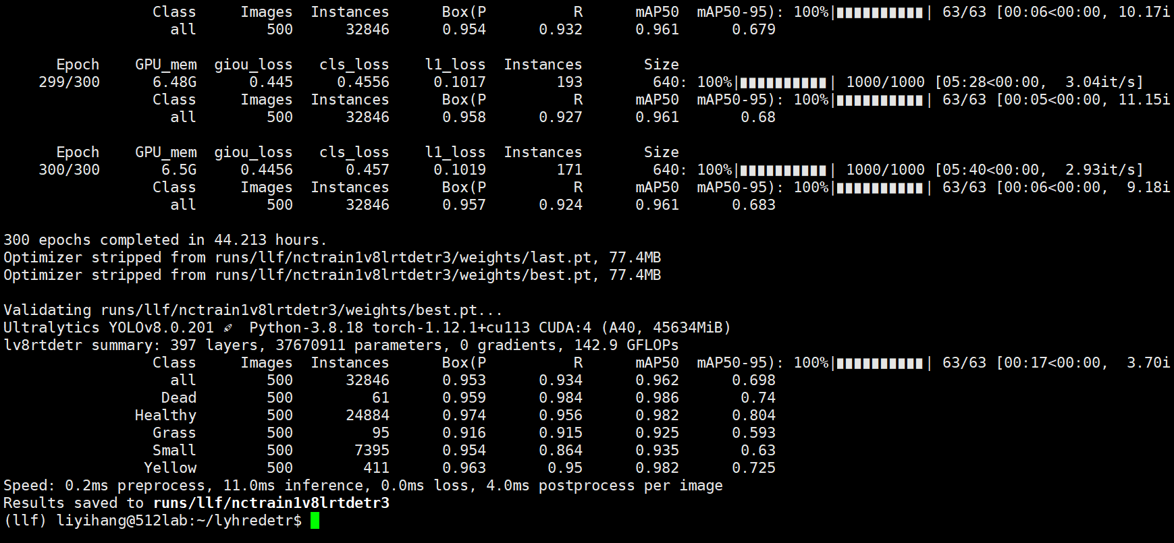

1. giou device4

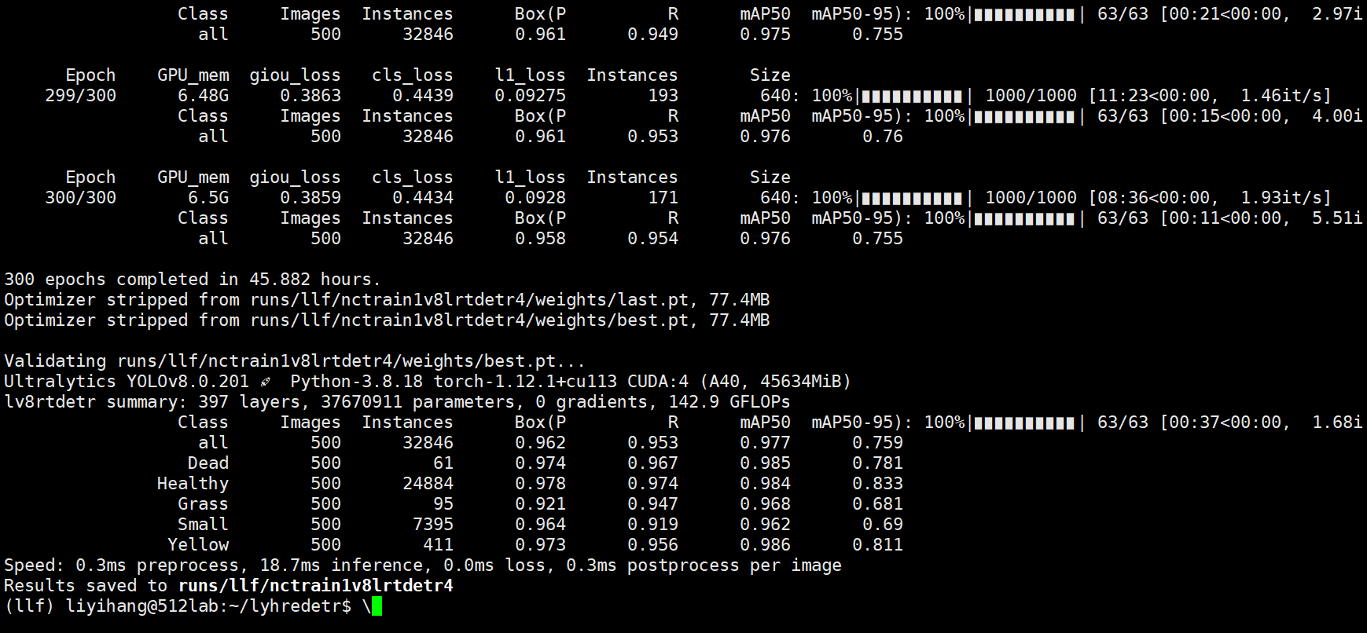

[r50 ]

1. aifi换成一个东西

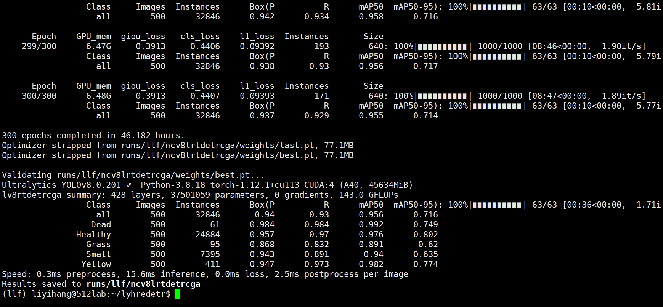

1. c2f换irmb-cascaded

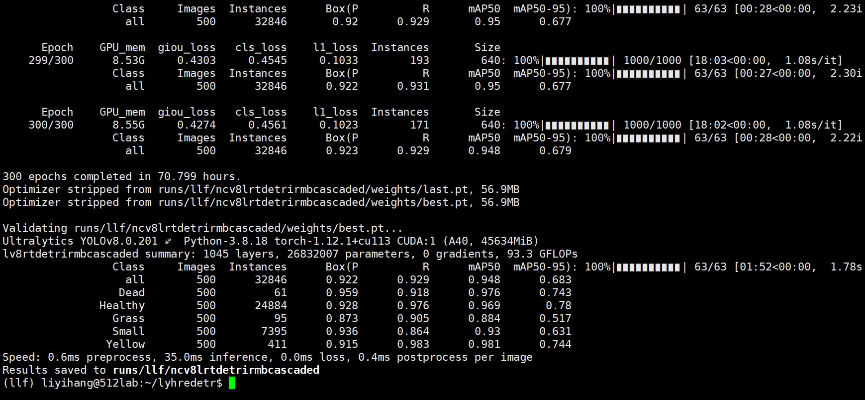

1. device =5 repc3换成csp_edlan 4个模块

计算量少了

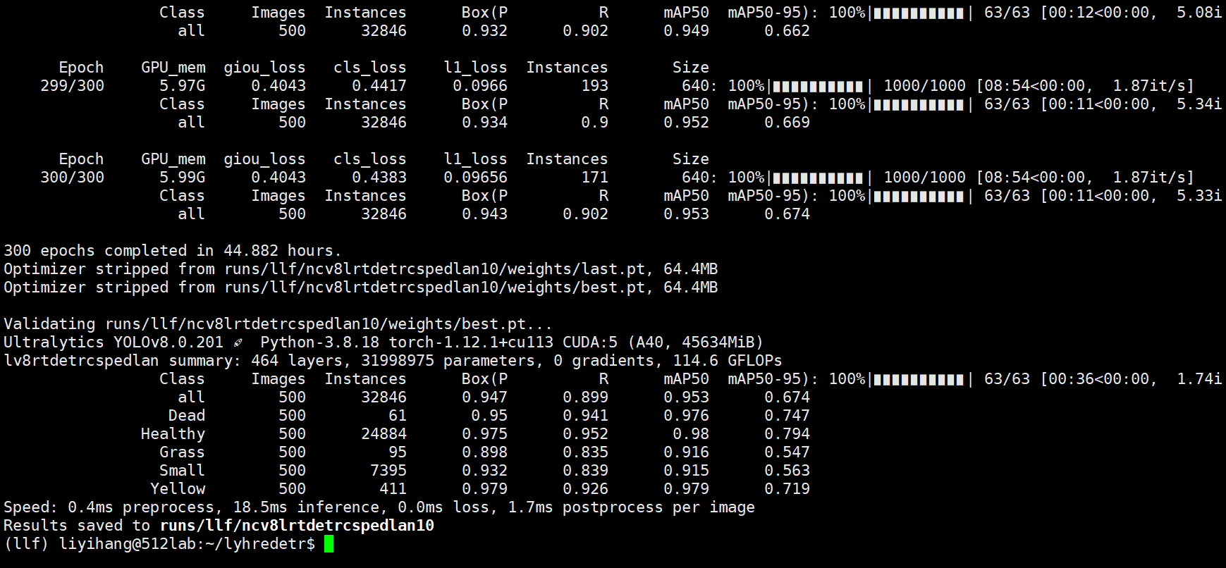

nctrainv8rtdetr3.py

1. device =5,repc3换成3xcc3

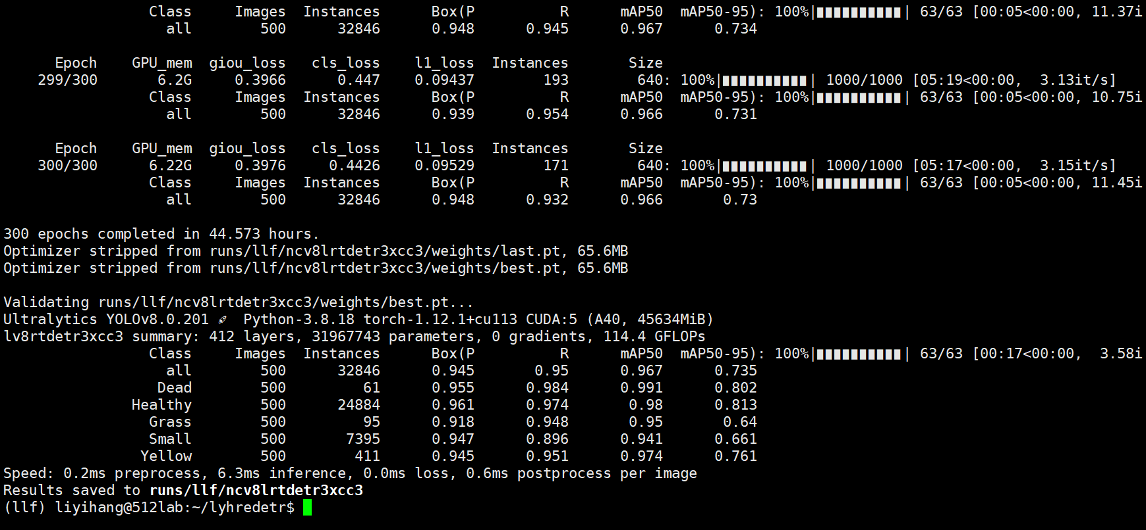

1. ple再试试,device=4
2. device =2,loss=sim 0.8

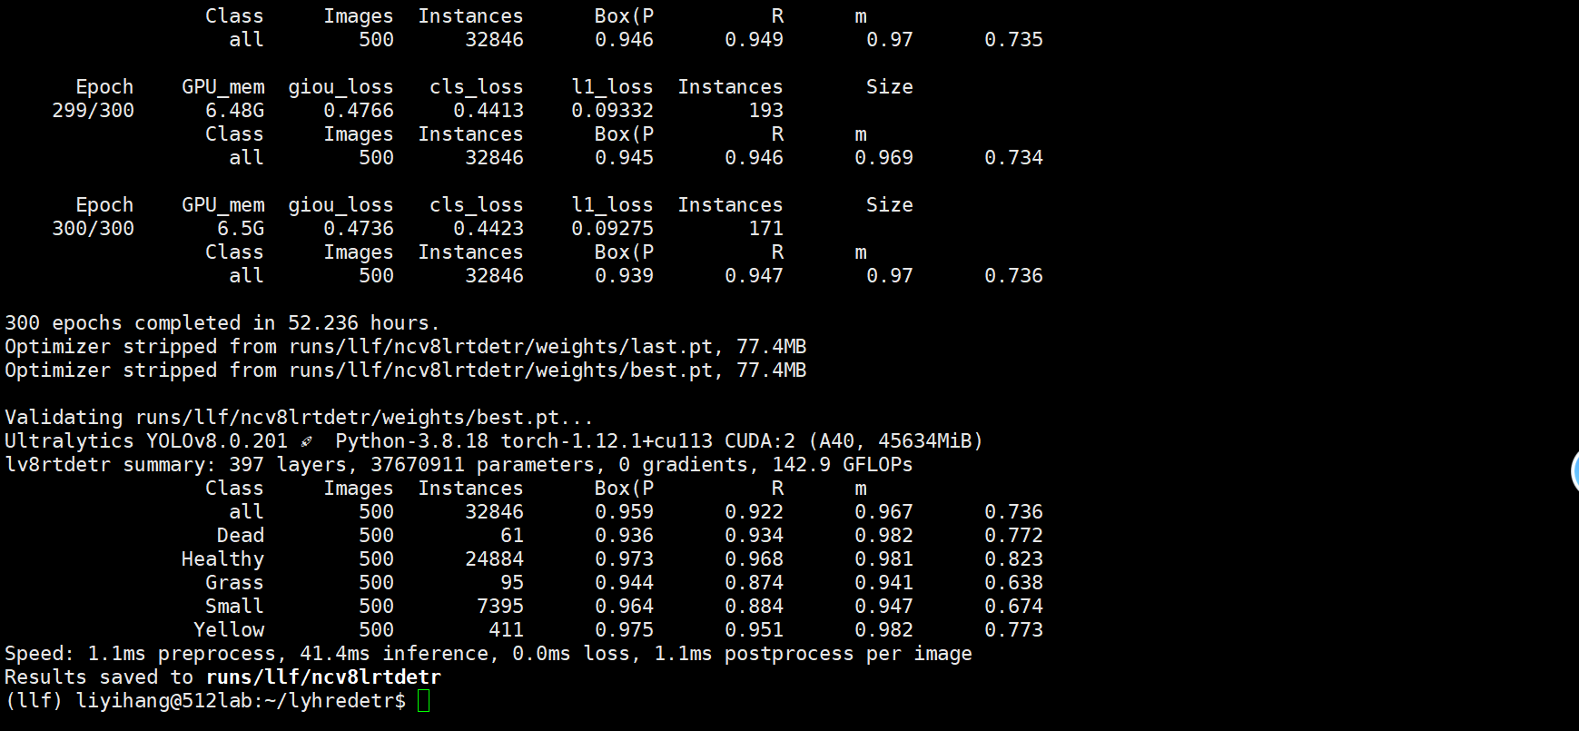

1. dattention(这个是sim) 7.py

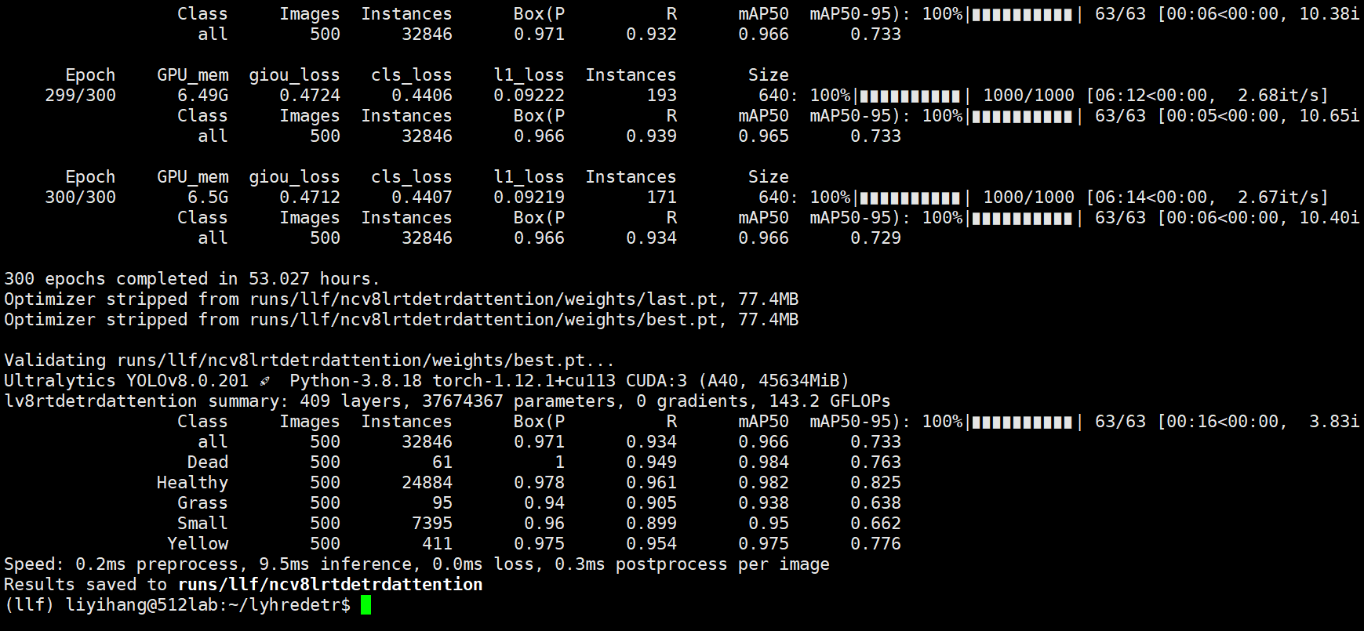

1. dattention giou 77.py

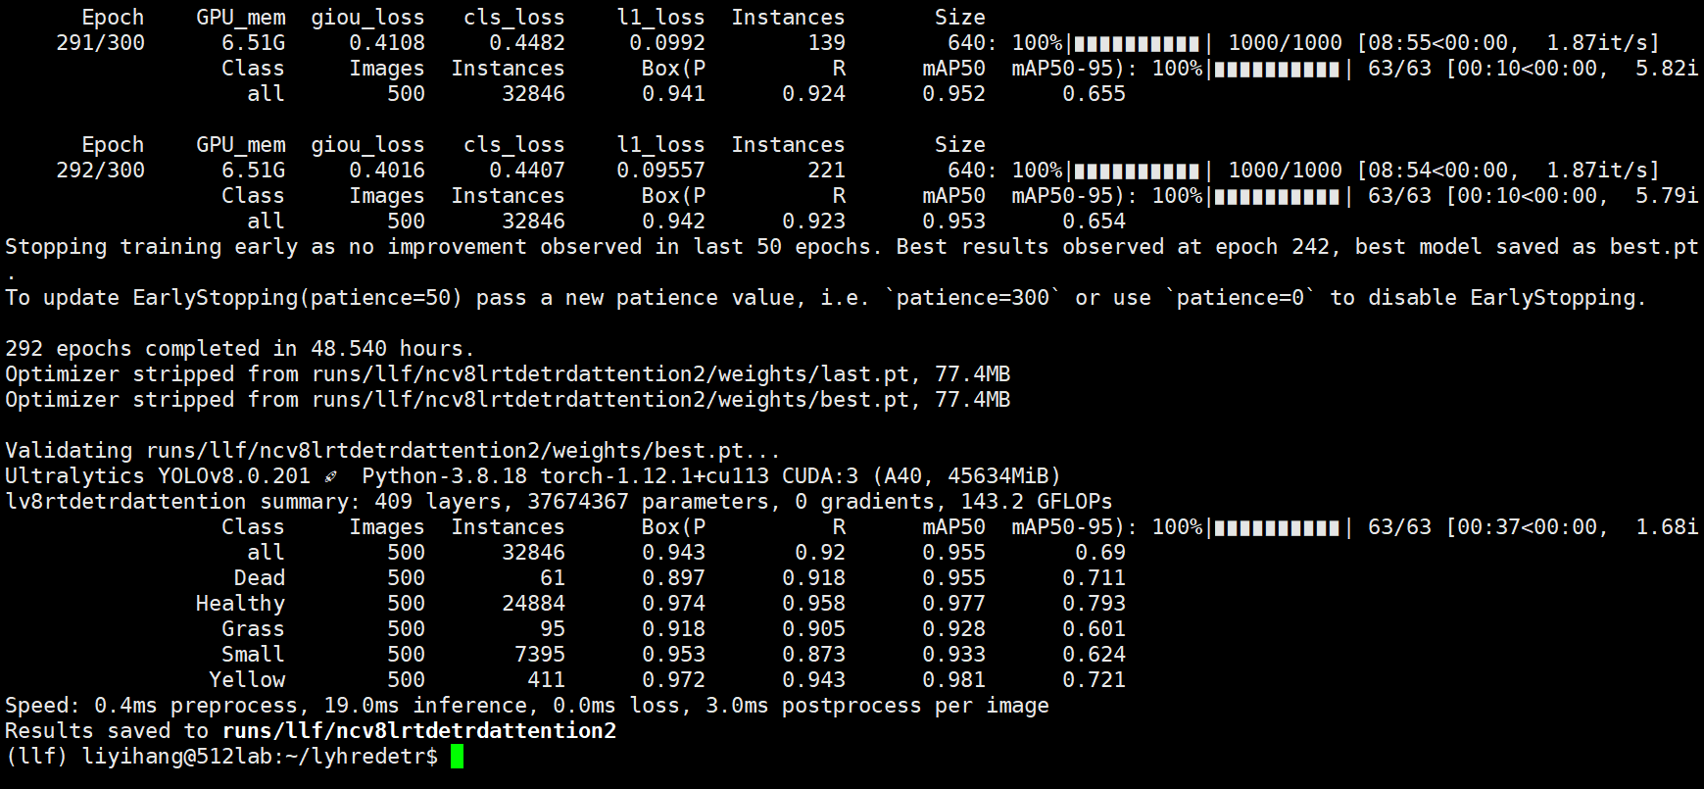

注意：dataset的路径、yaml模型文件的路径有nc和没nc

1. visdrone v8l rtdetr siou 8.py

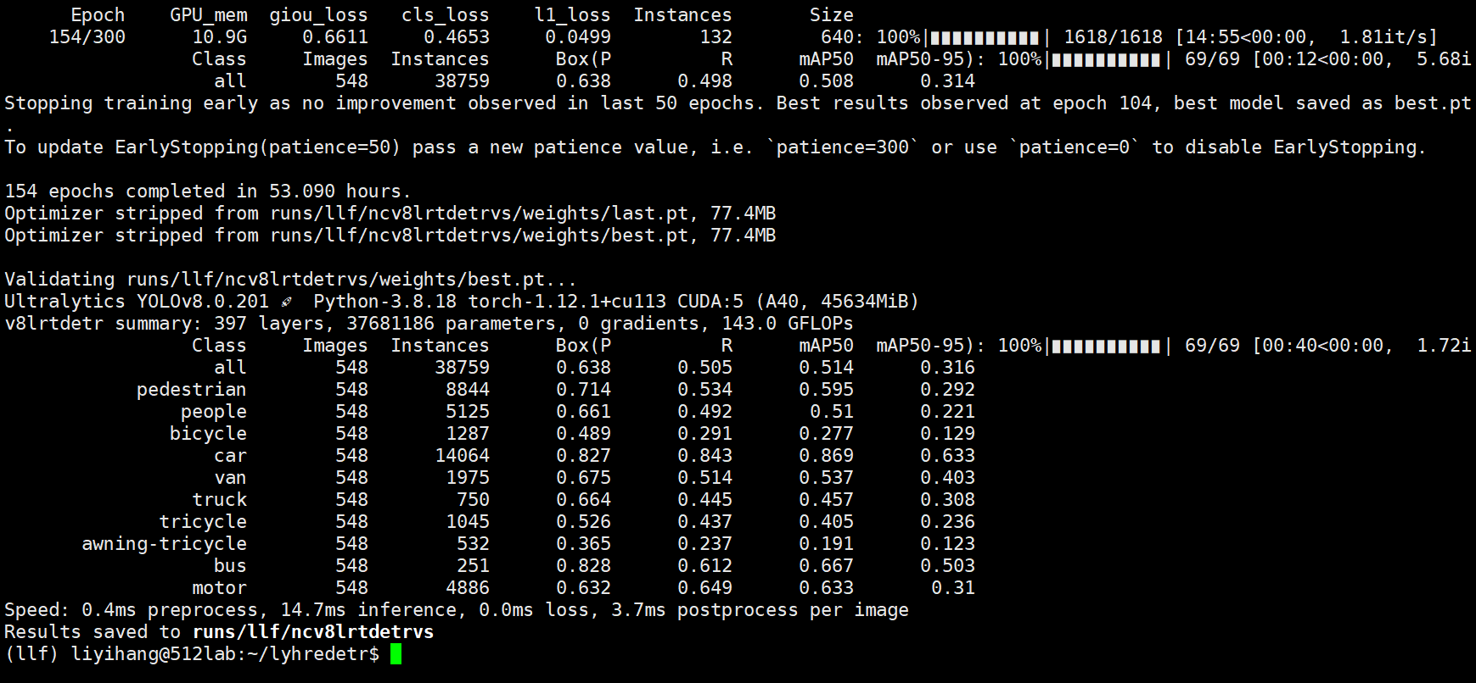

1. visdrone v8l rtdetr giou 9.py

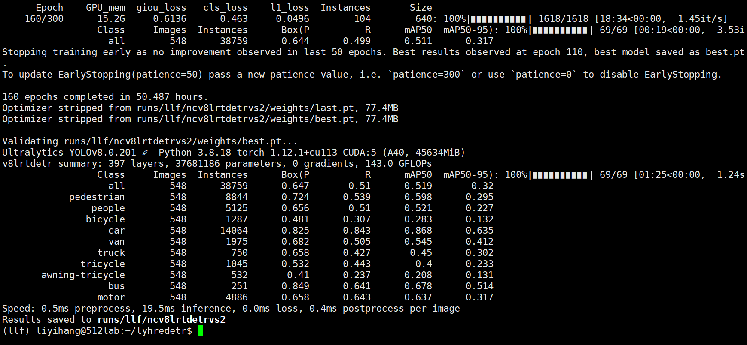

1. loss=siou

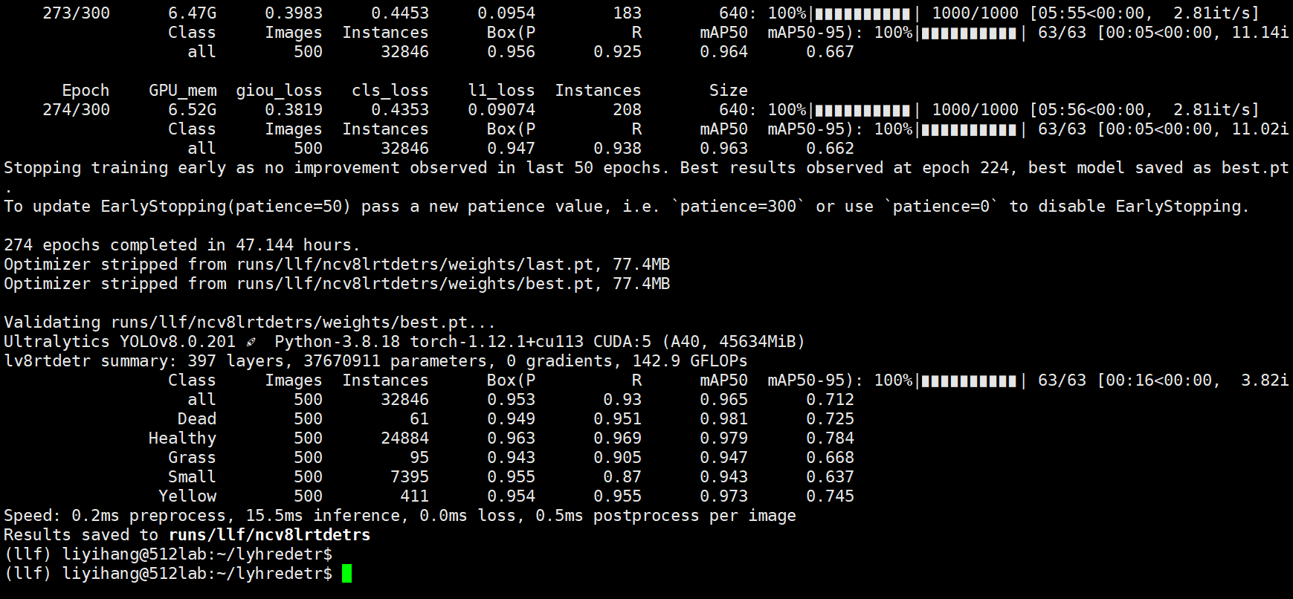

1. siou+inner+mpdiou

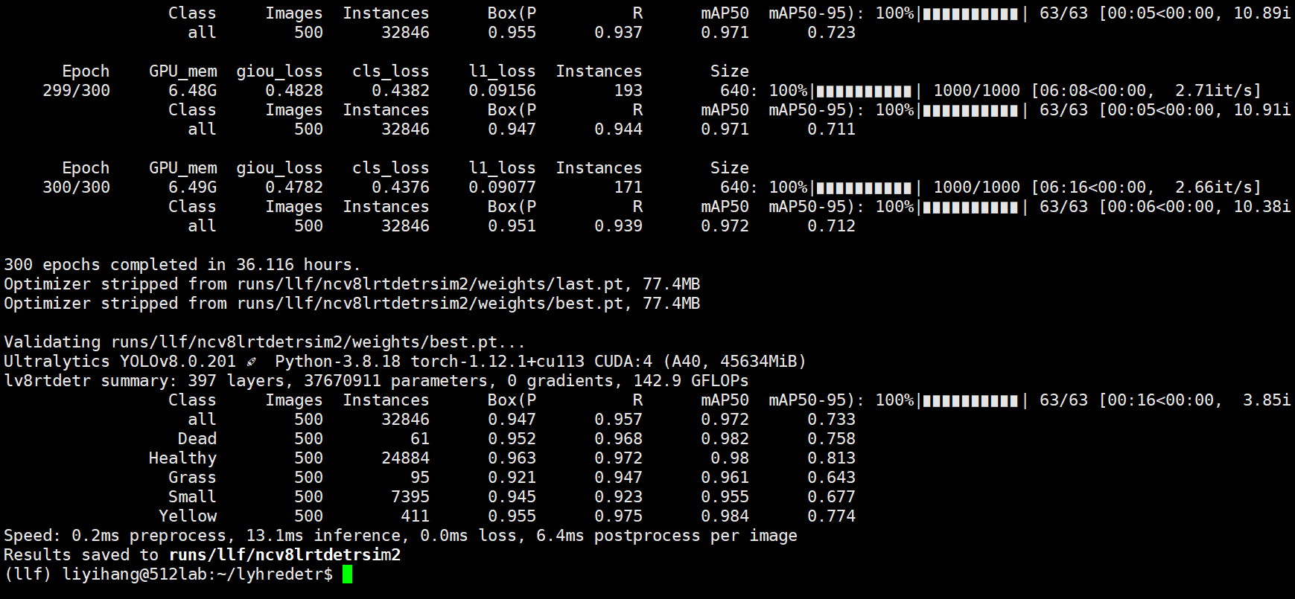

1. v8

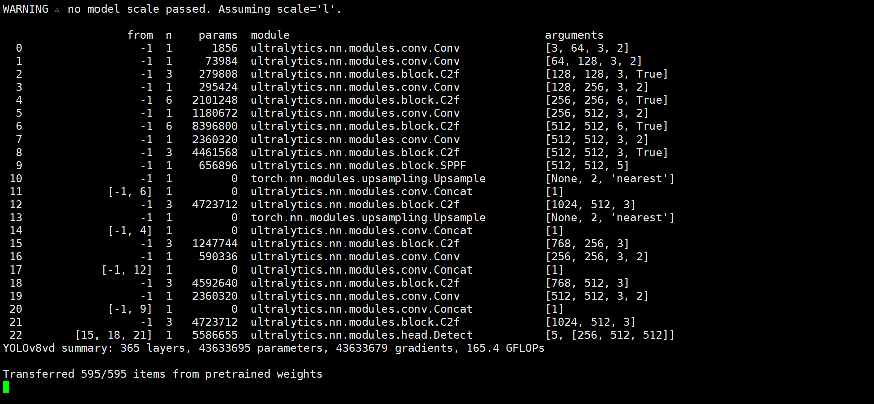 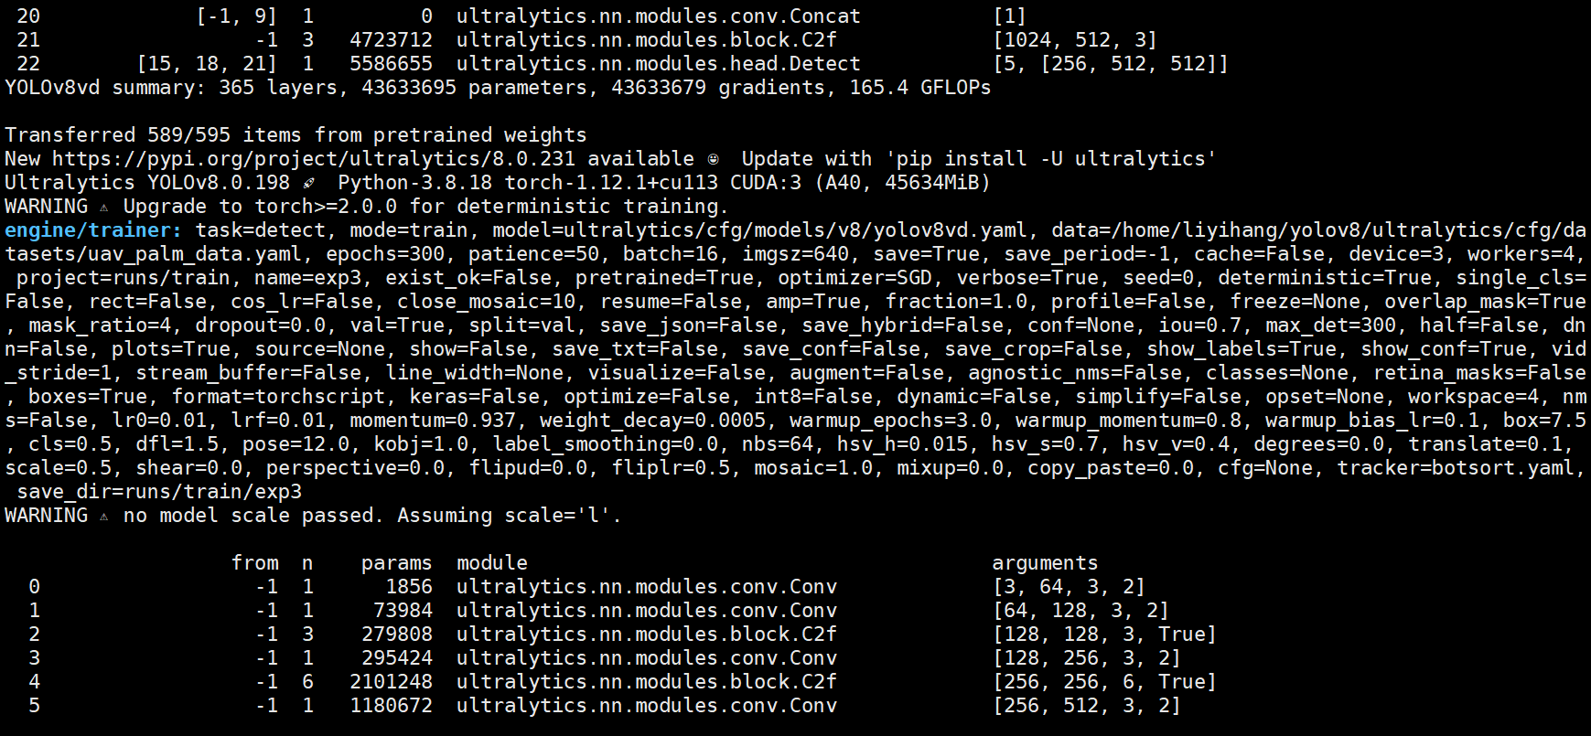

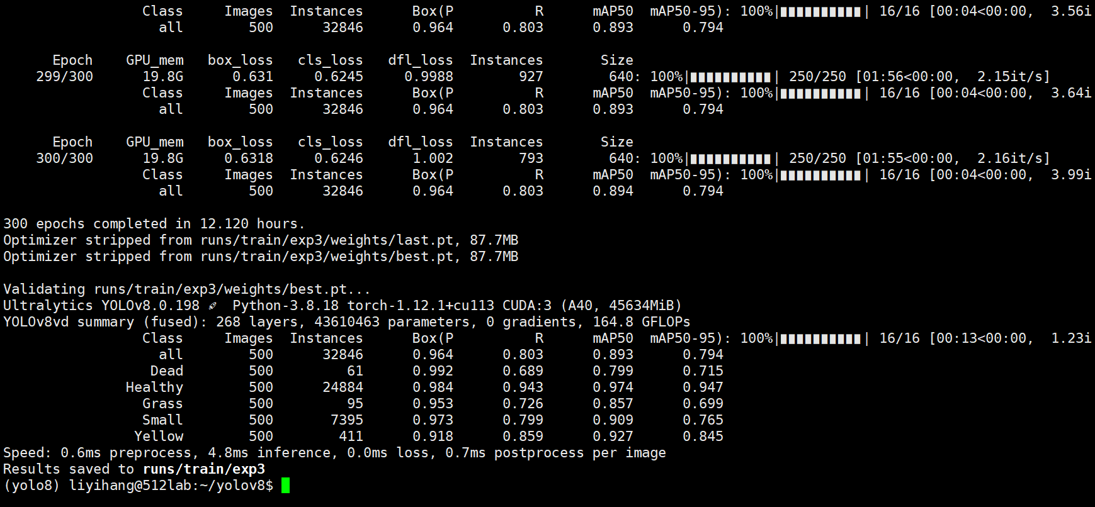

batch4:

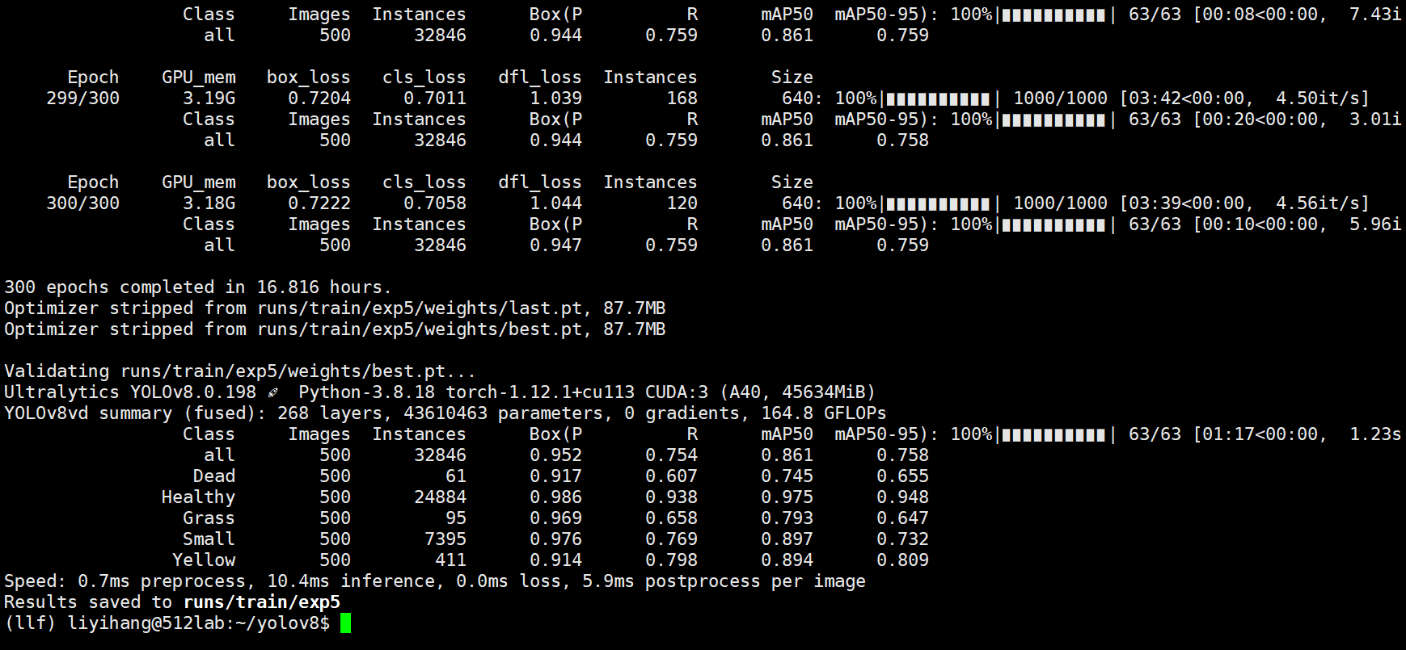

rtdetr -18 epoch=72 map=0.24 2M

yolov8n 6M map=0.19 epoch=300

rtdetr-50的预训练权重高，

27 v8l visdrone batch=4

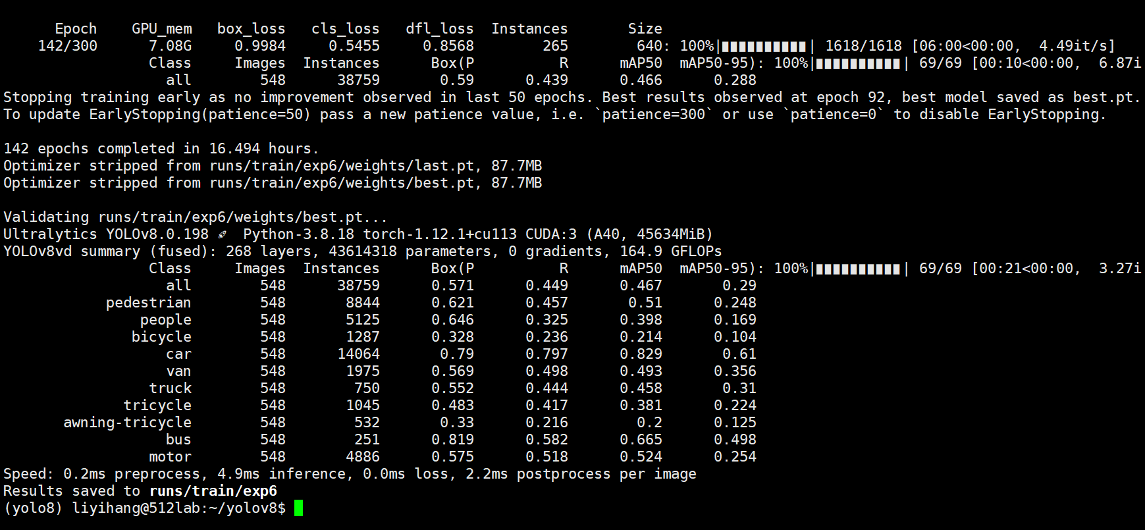

new01:

device=5 ,sim k=0.95

1. py

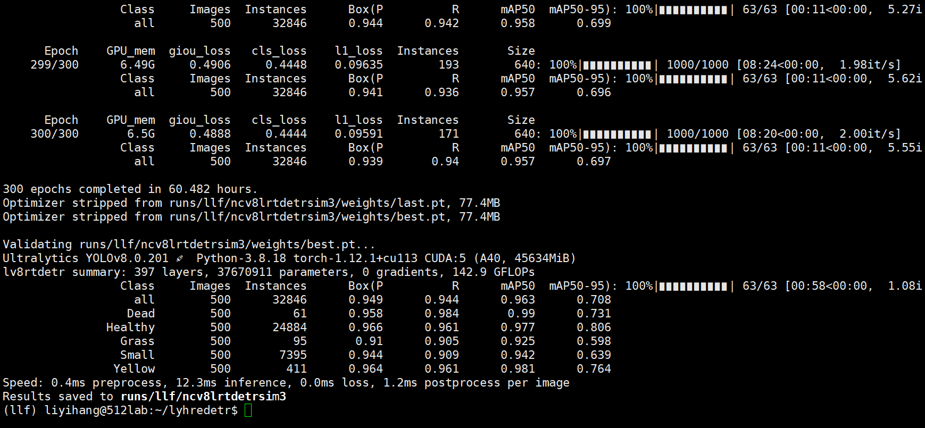

new02:

yuan

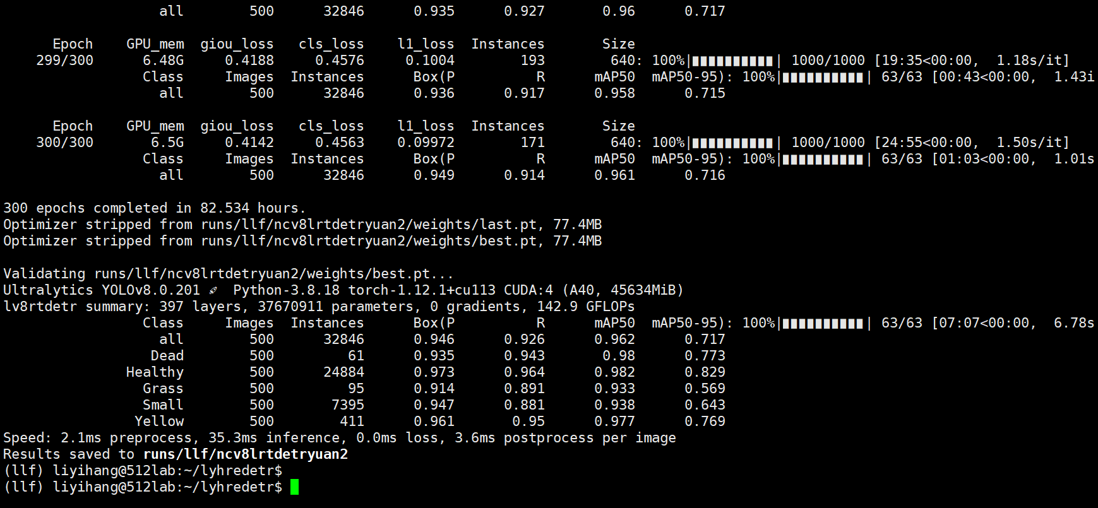

new03:

r-50



注意weights要改

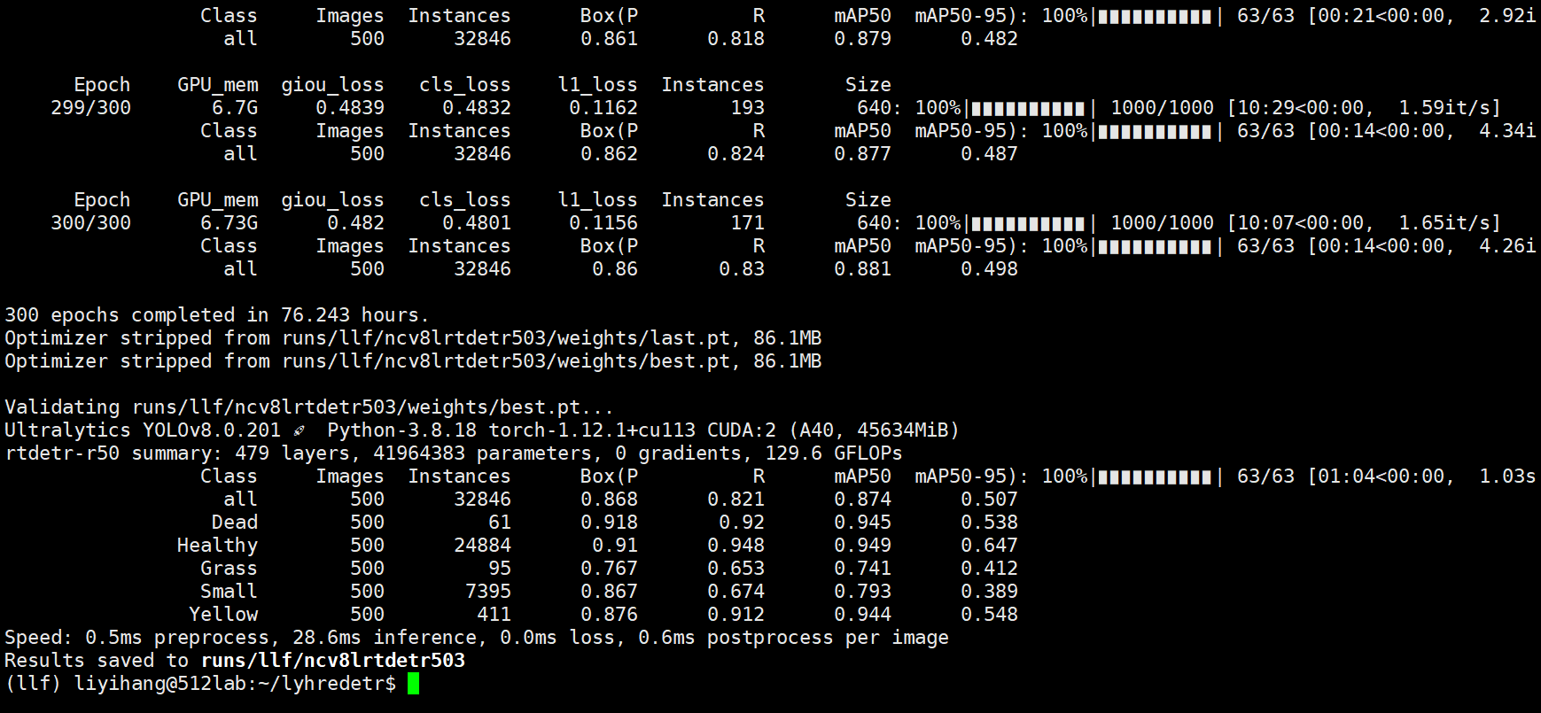

new04:ZE(zoom_cat)

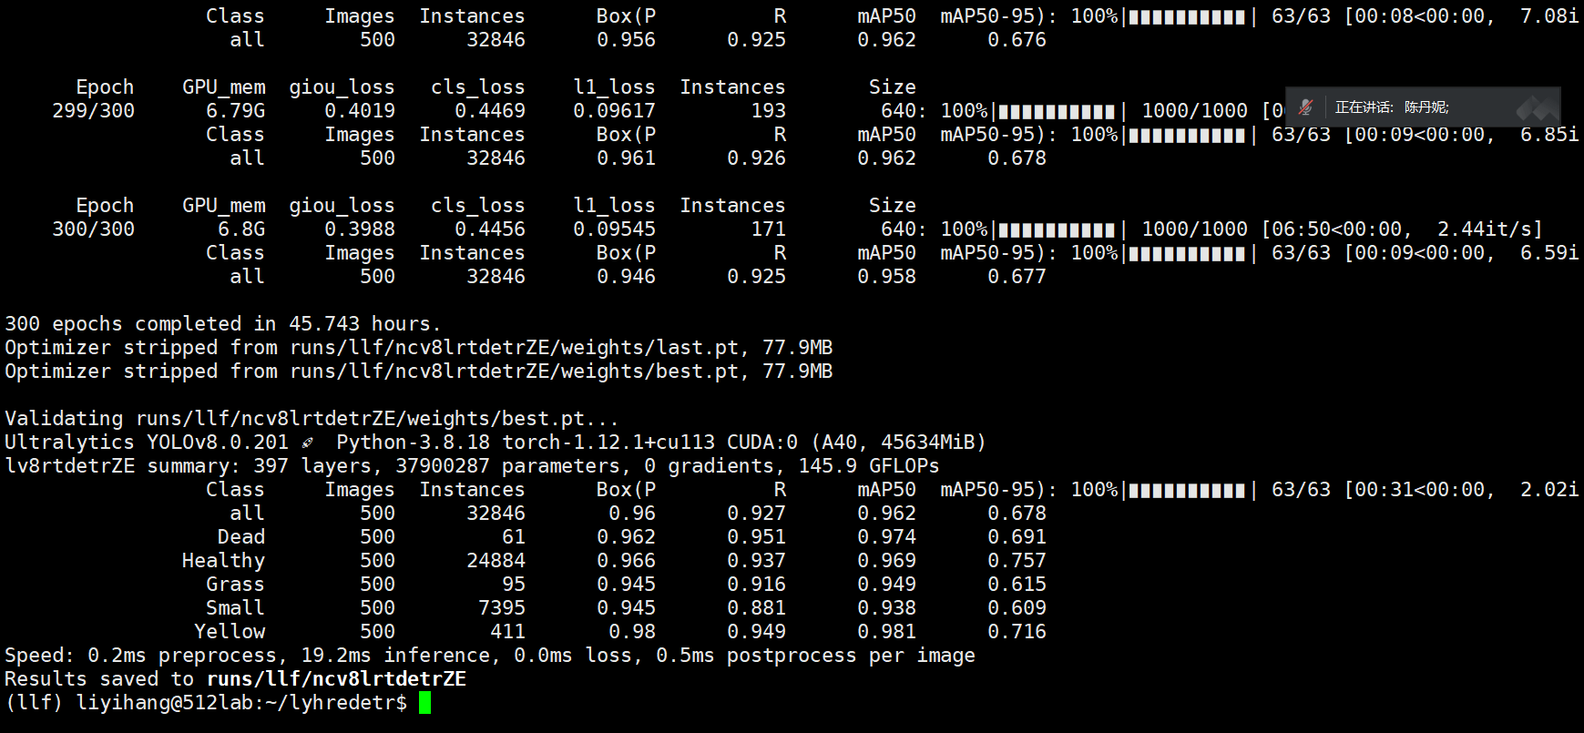

new05:ZE+CON3CX+IMS-iou(1.25+0.05)

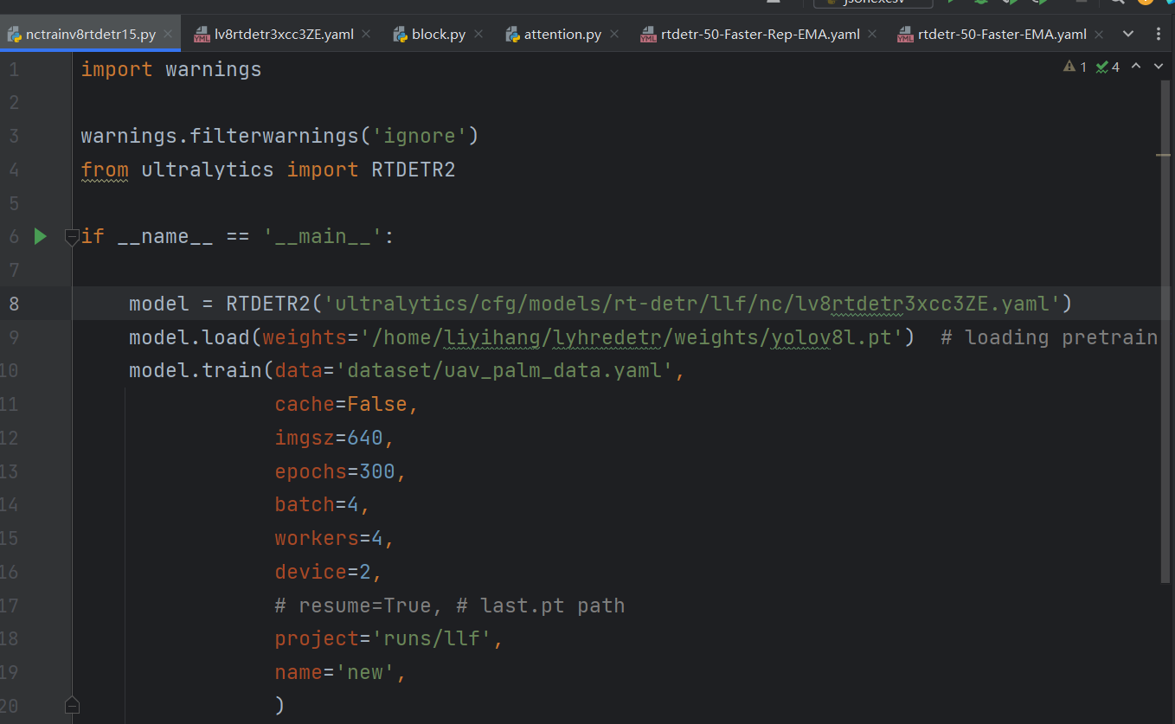

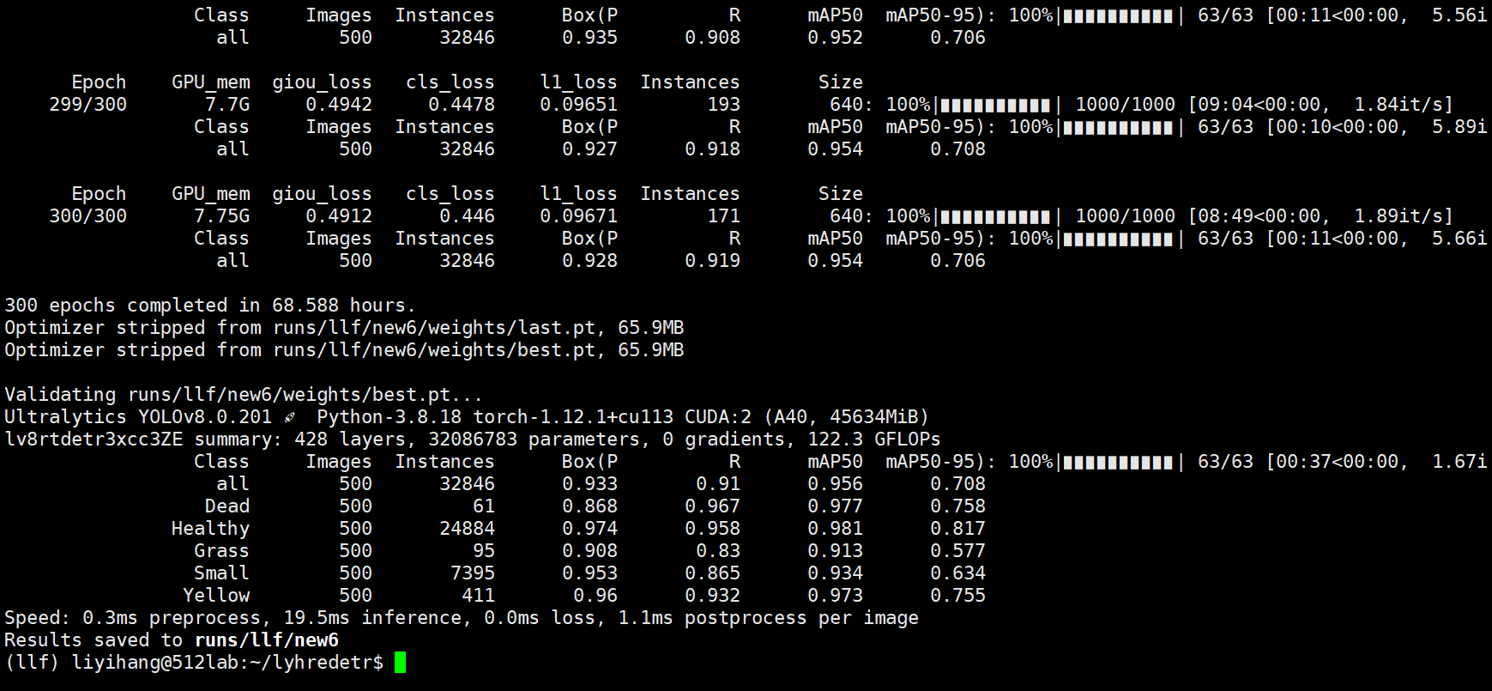

new系列：

A+B=Cxb

rep整改，损失函数参数计划1.25a+0.05b,考虑要不要加入法尔发

ZE+iou

newyuan:

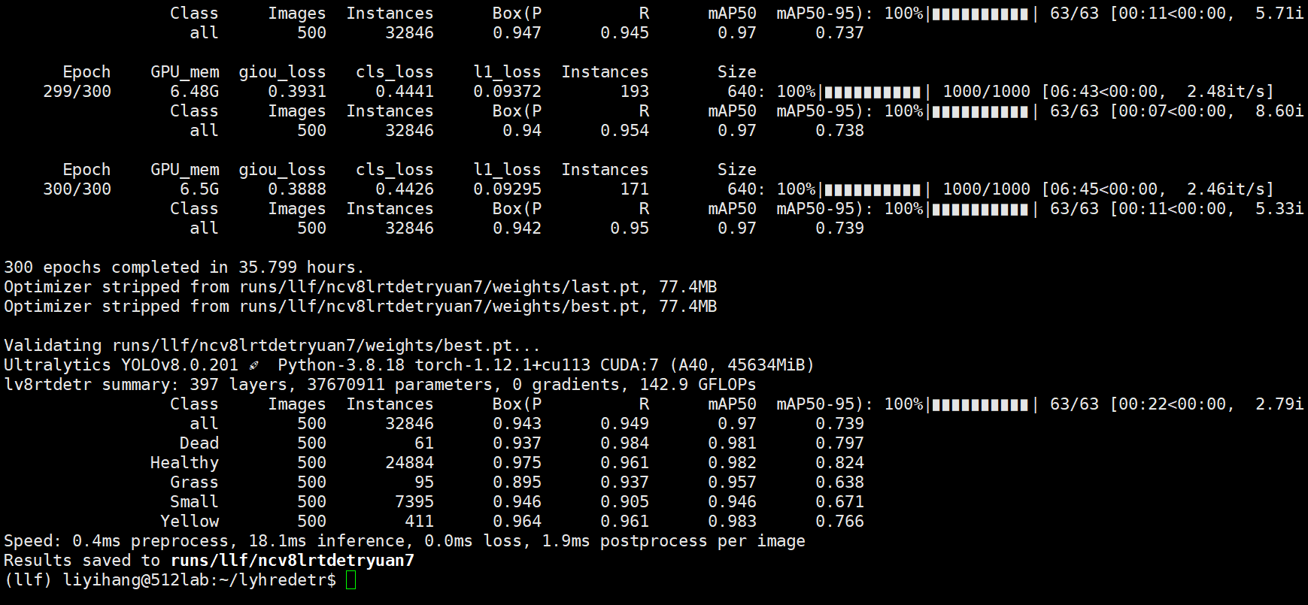

new06 IMS-iou

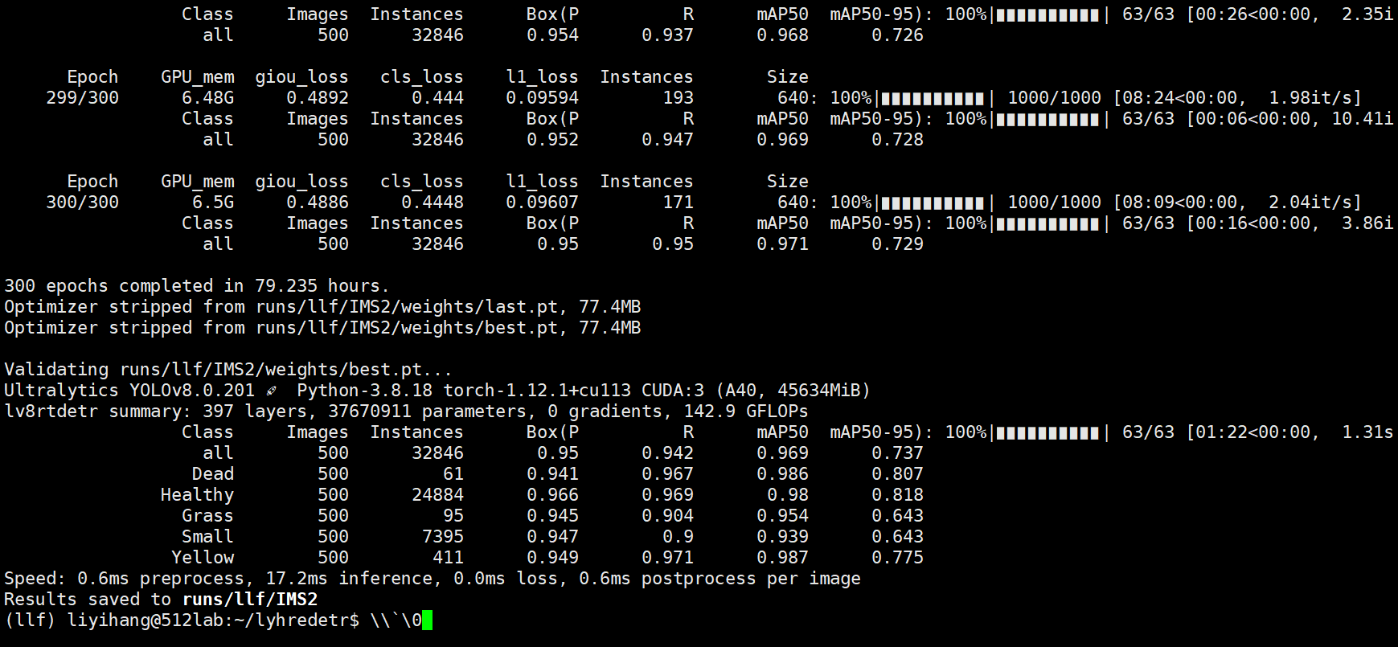

new07 (r-50.pt,device=0)

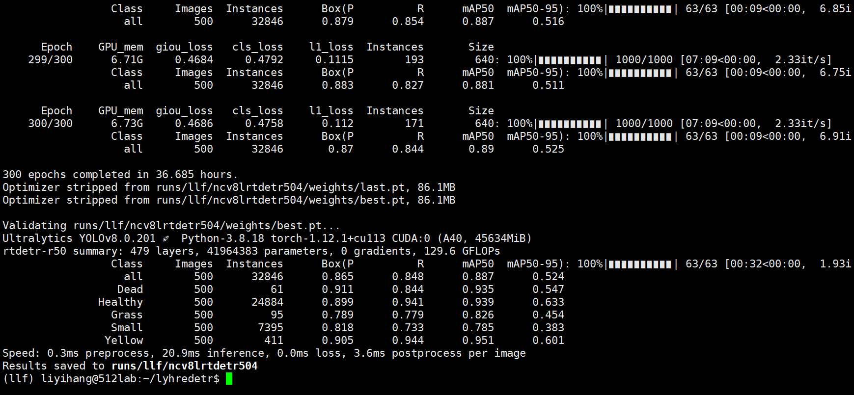

newnew

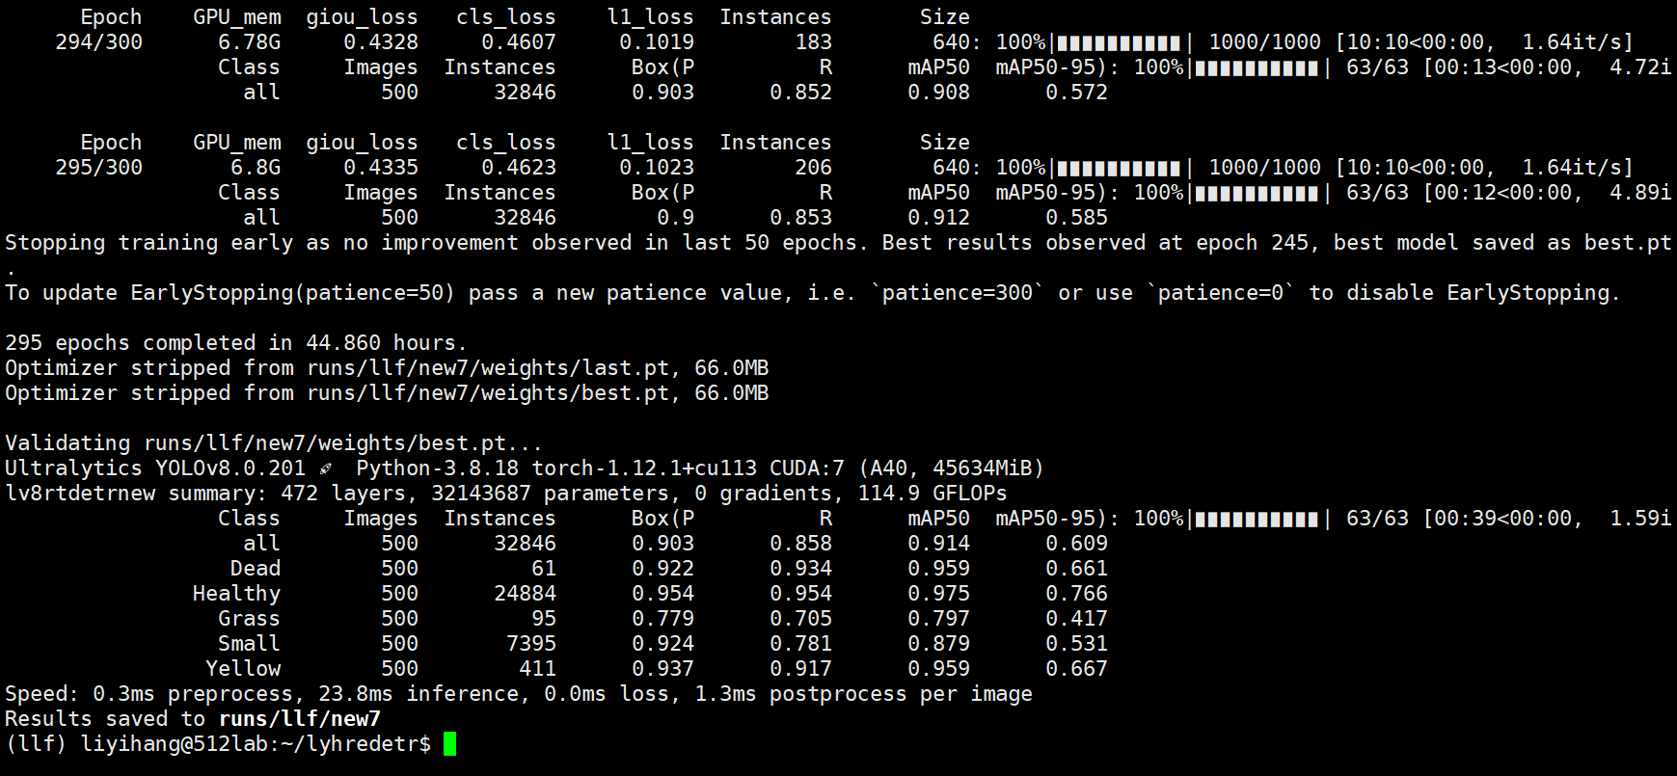

rtdetr-l



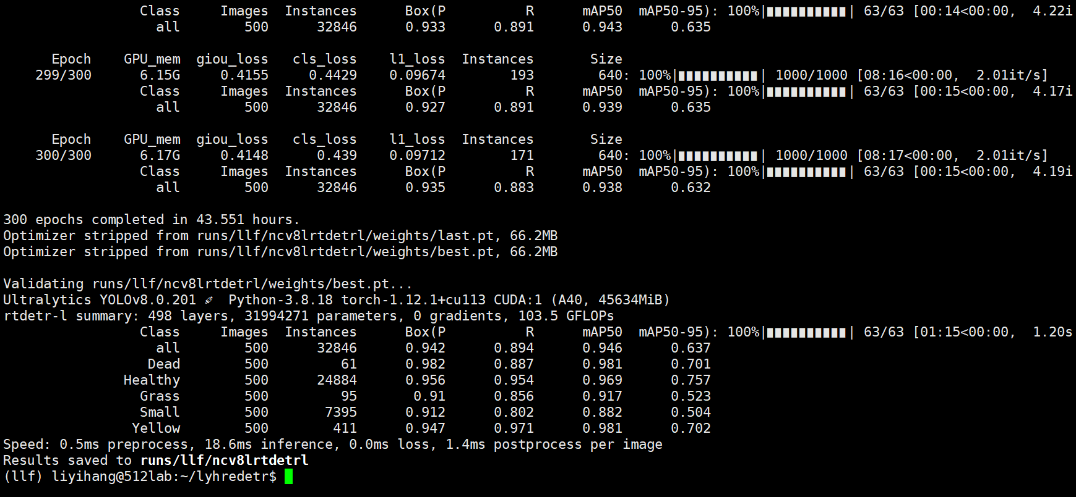

new08 new02.yaml

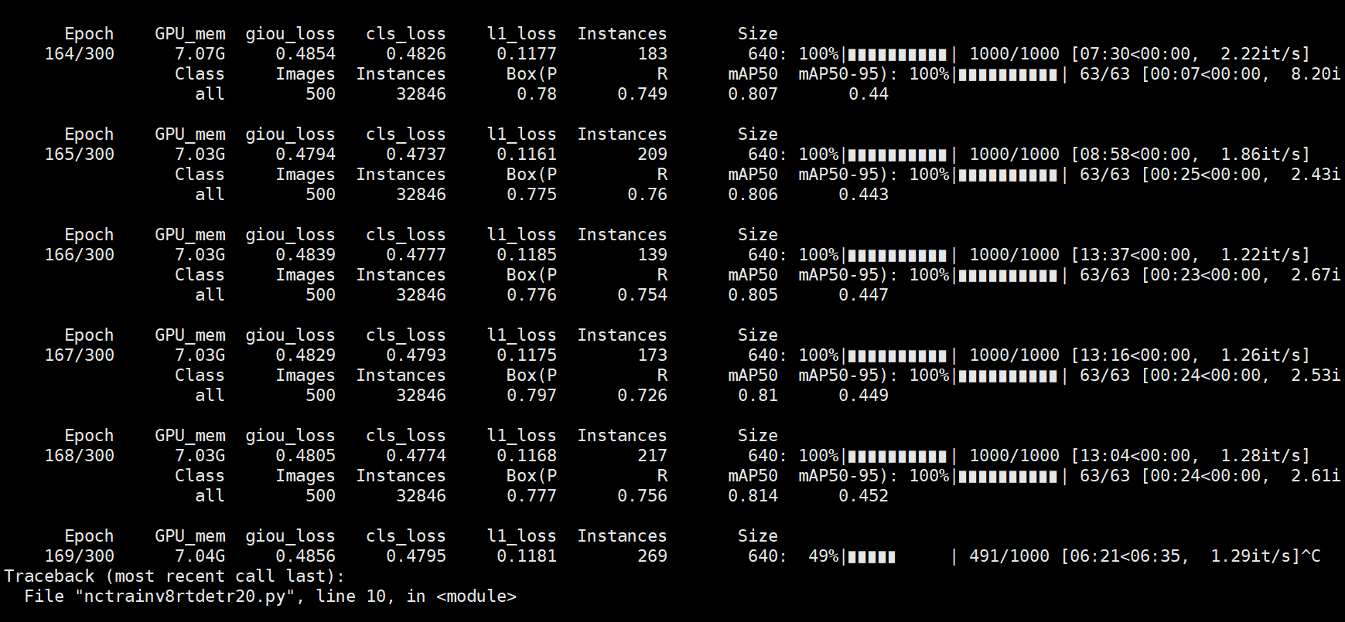

new10 sim(0.75+0.05shapecost)

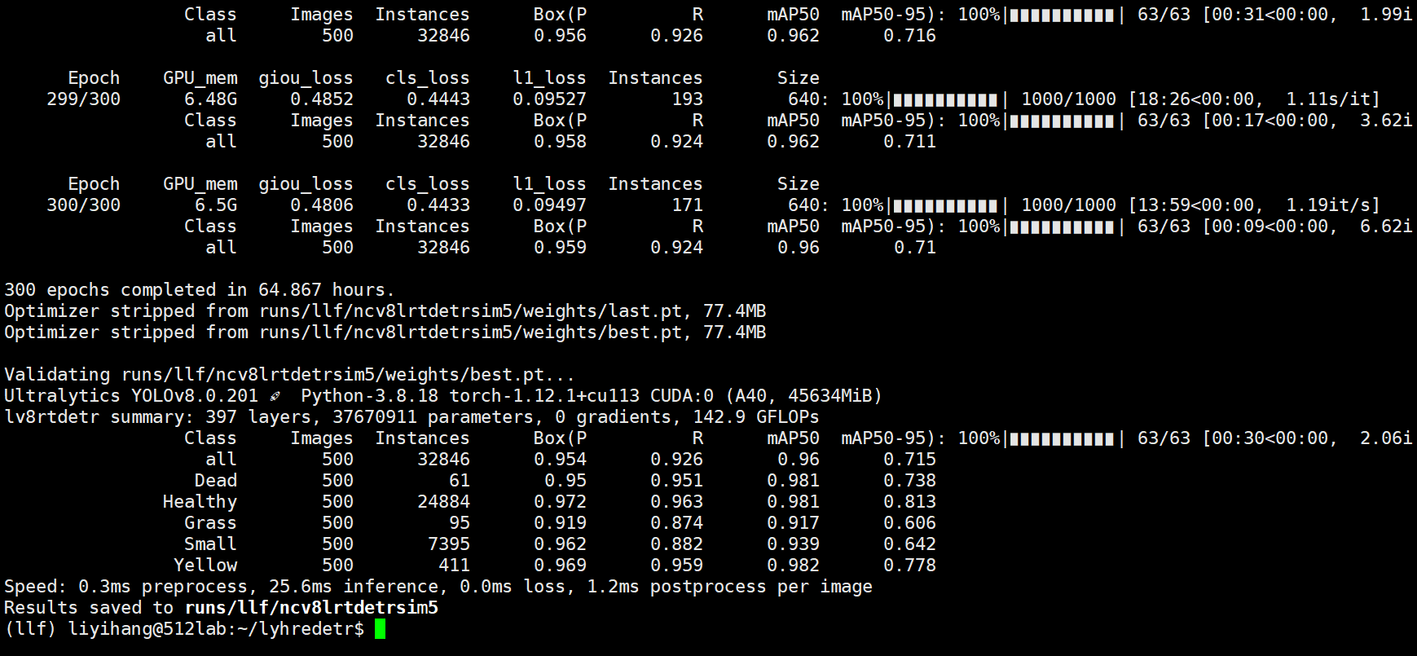

new09 c2f_DBB

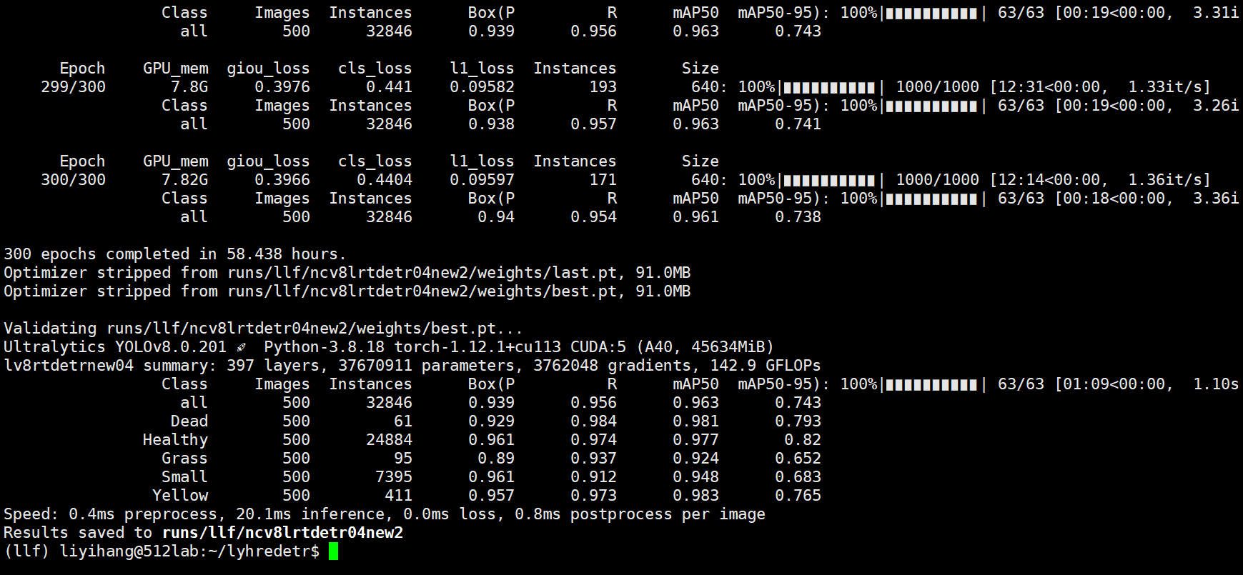

new11 SDI+seq

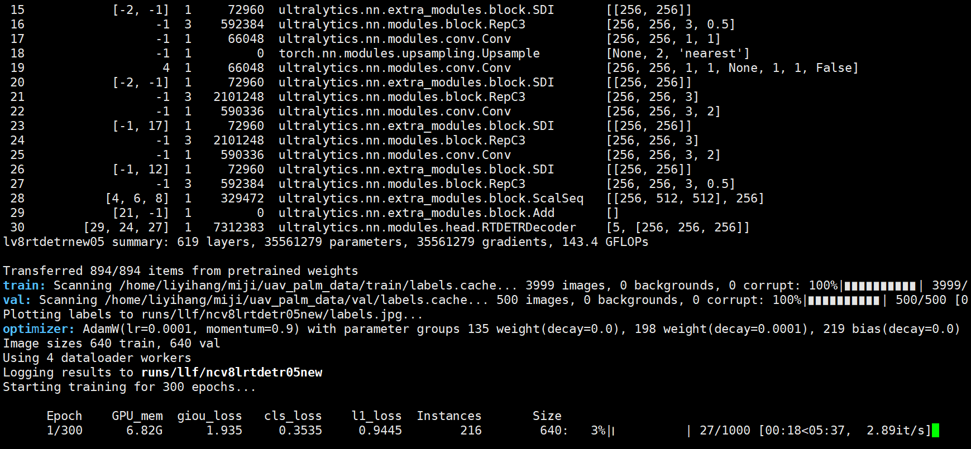

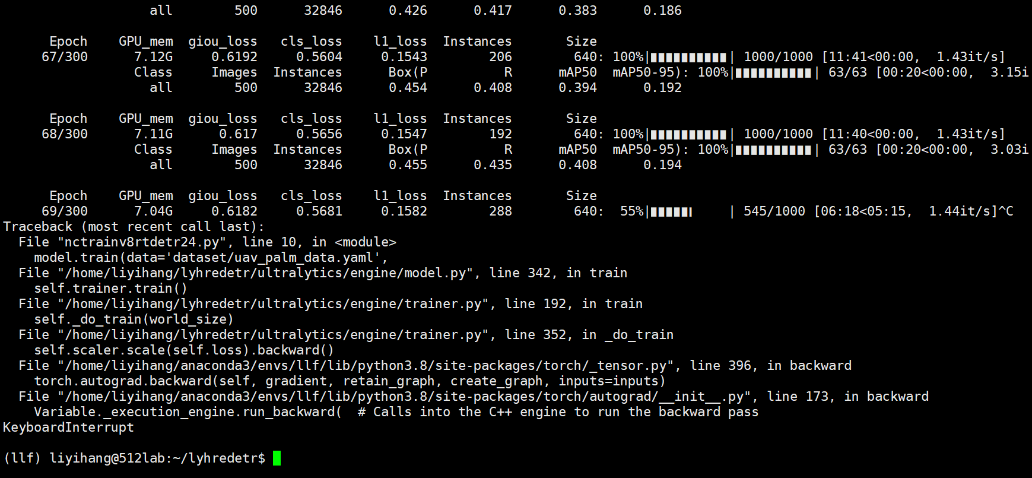

new12 visdrone r-l

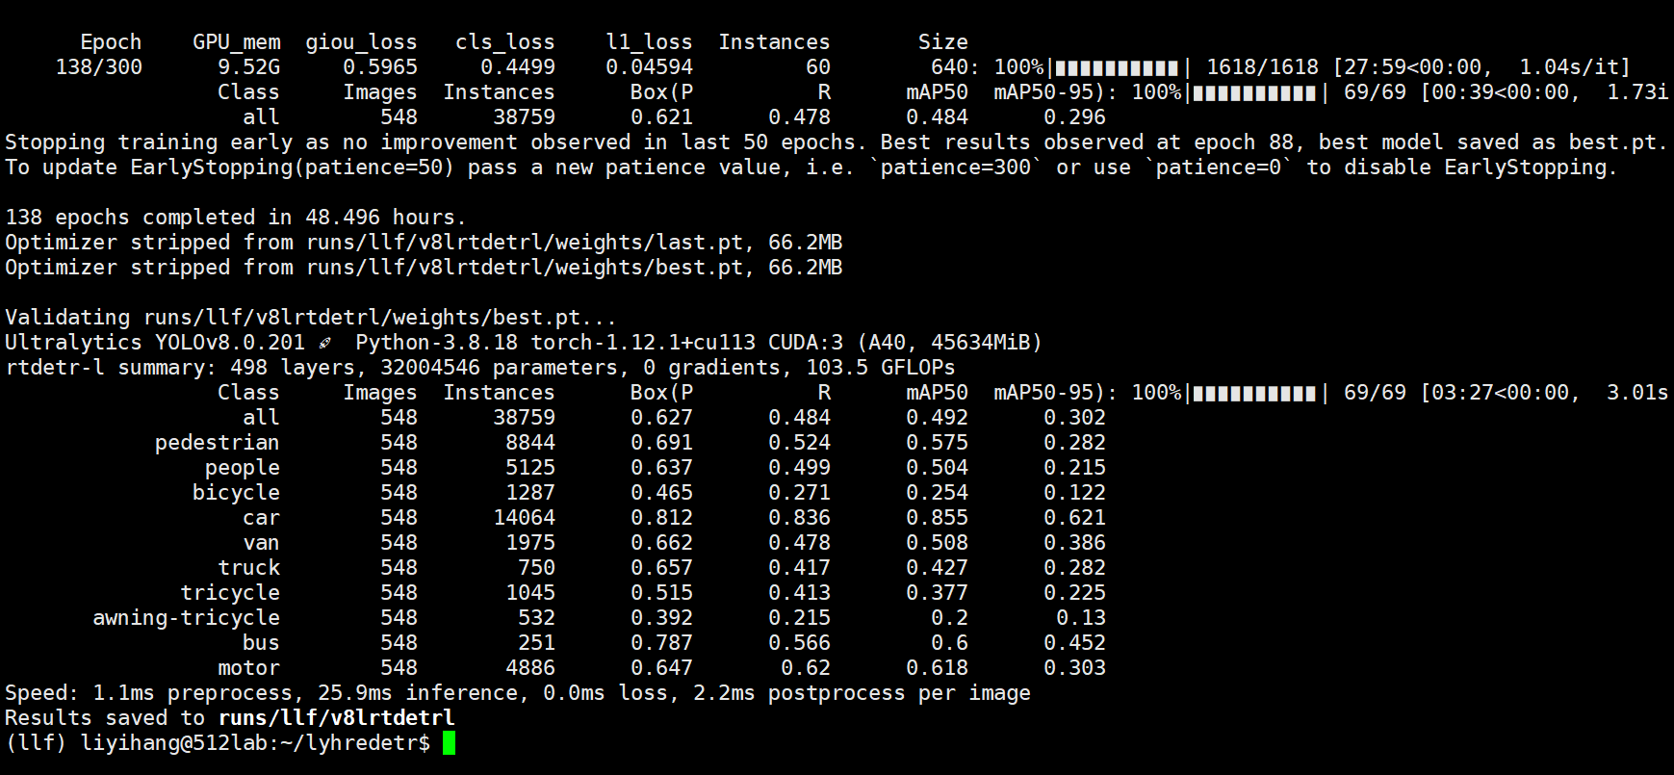

new13 fsm carafe



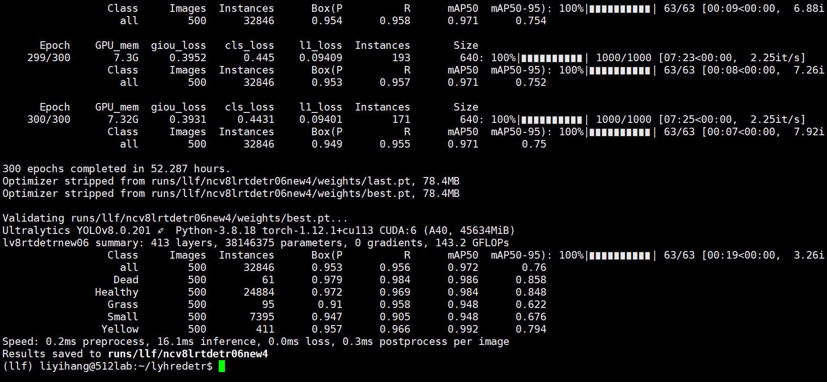

new14 dattention

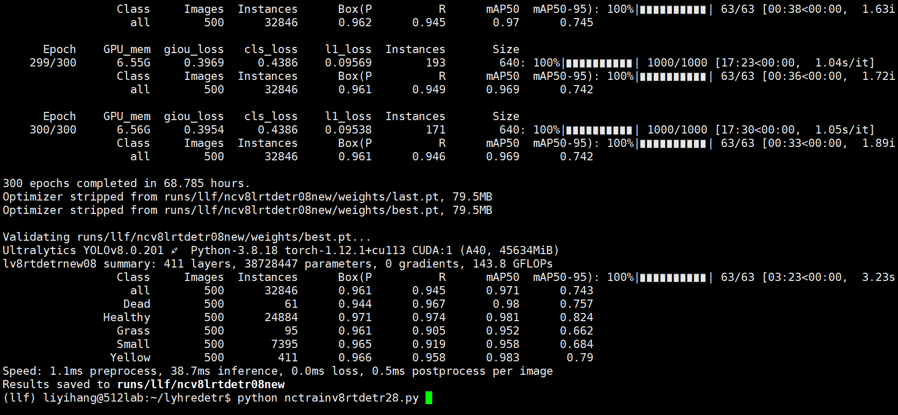

new15 bujia dat

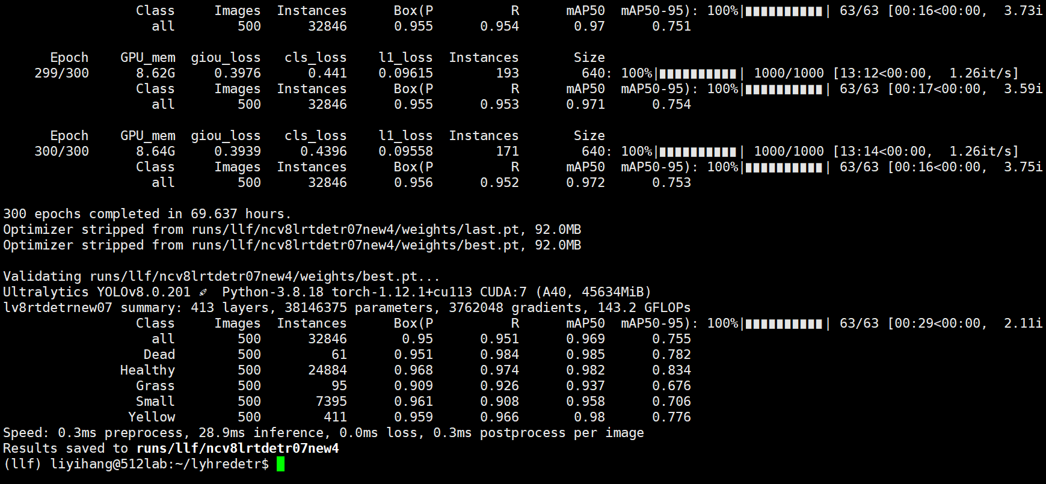

new16 jia dat

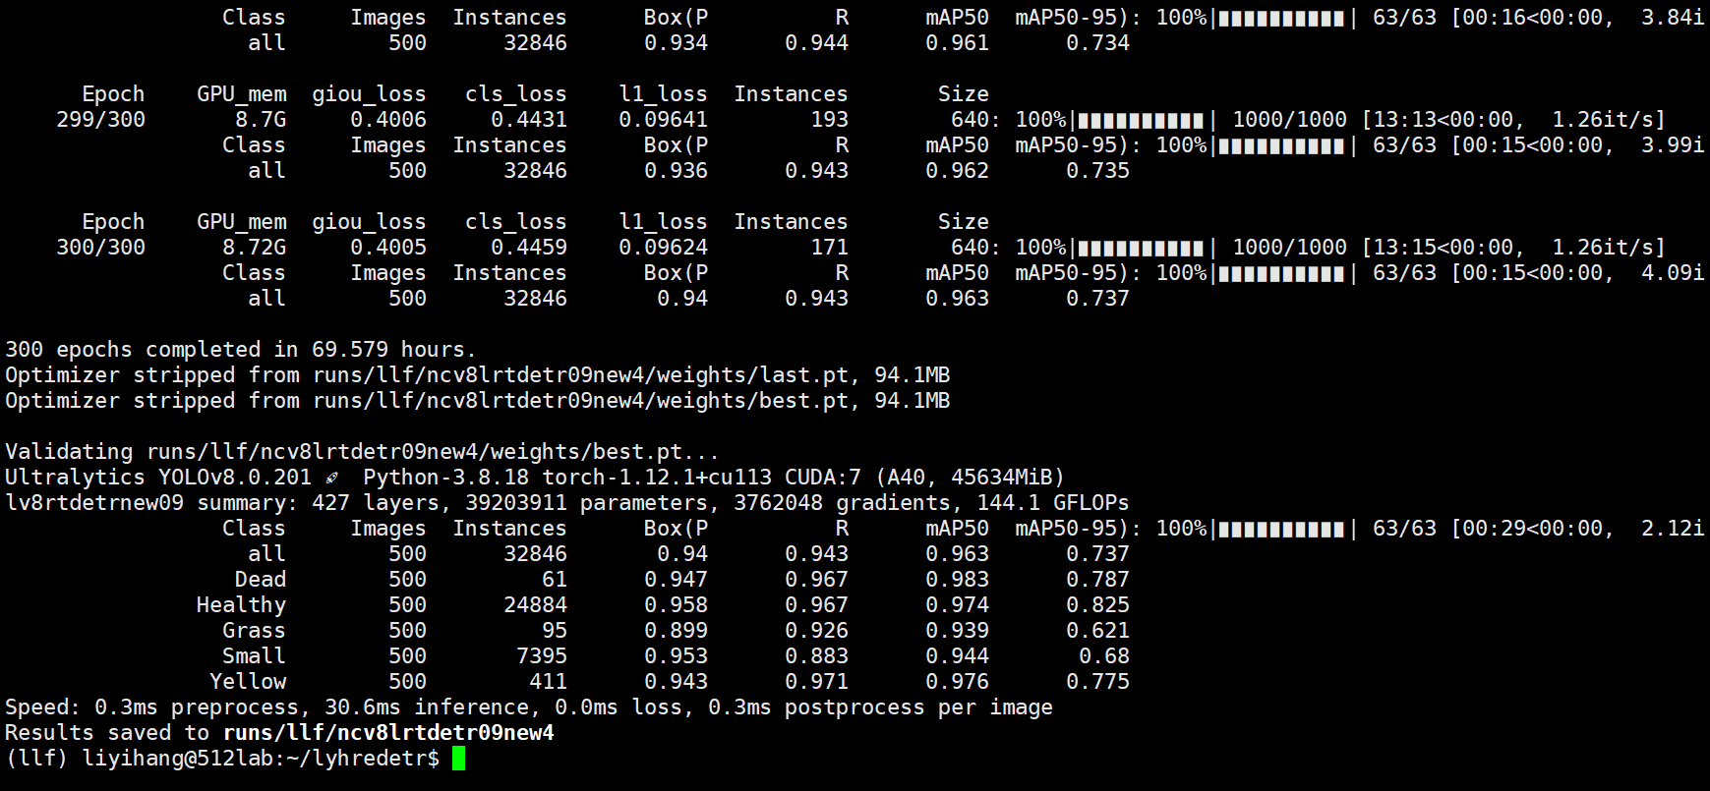

2L:rtdetr2loss

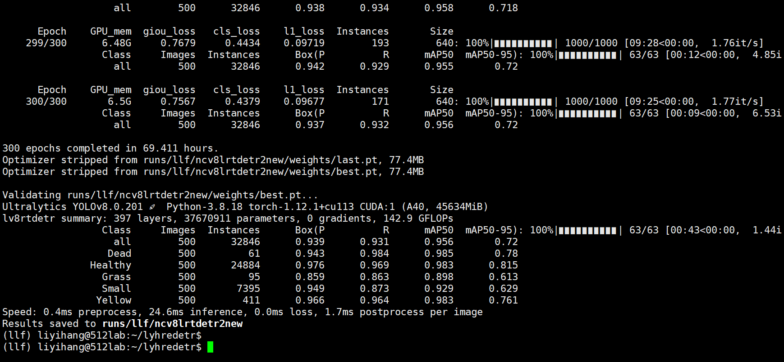

3l:

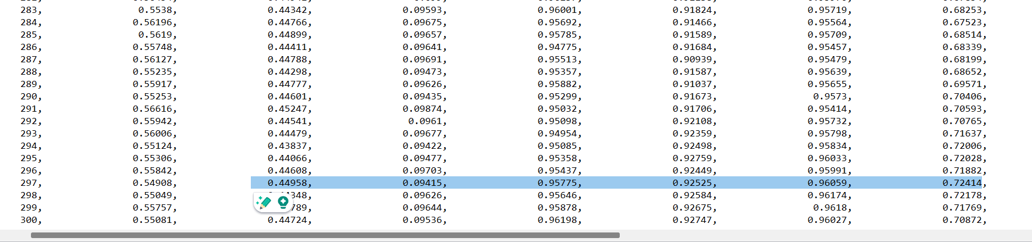

sahua:bujiadat+rtdetr2loss

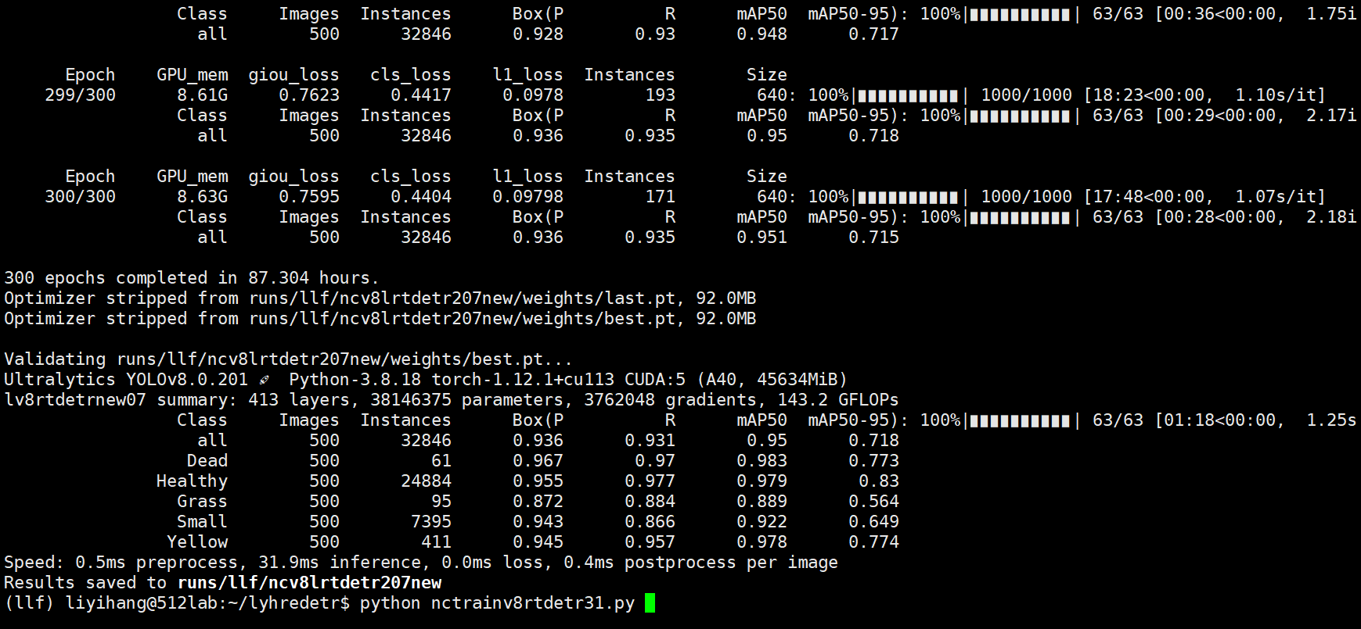

v7:

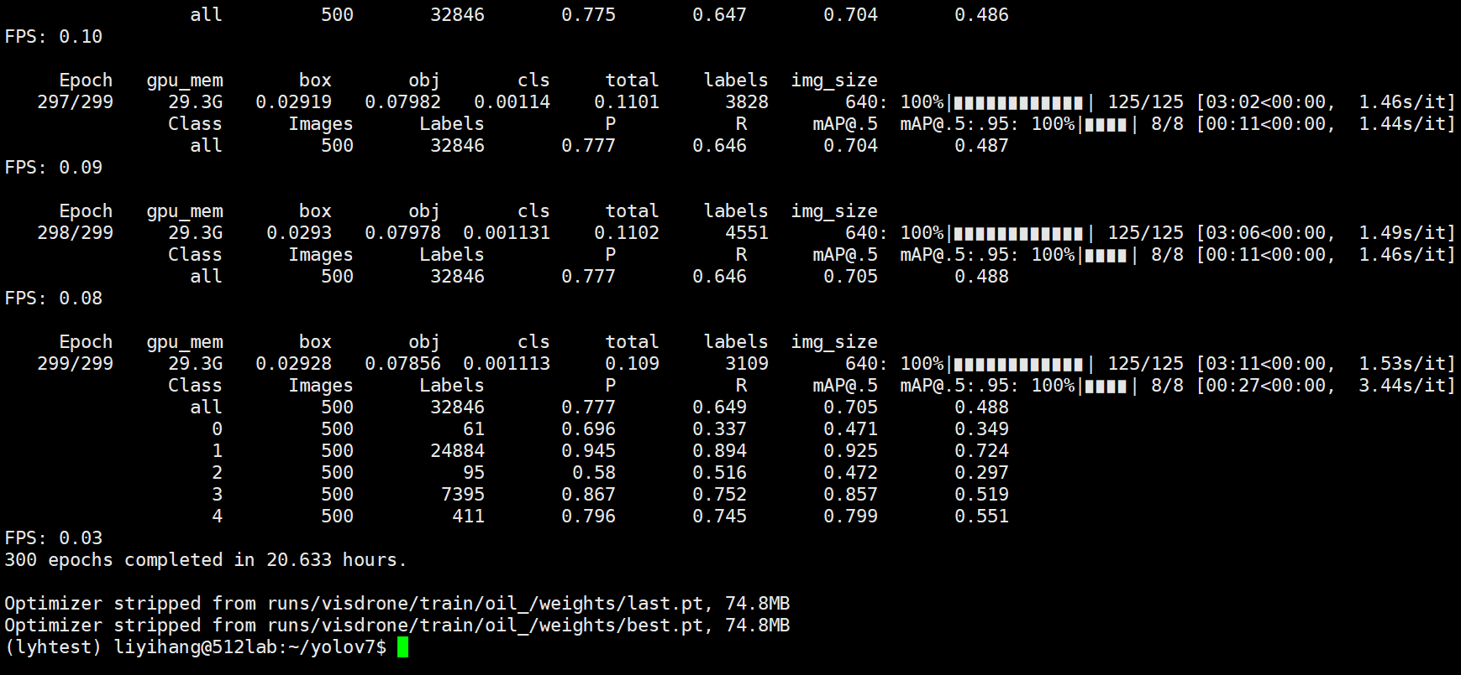

c2fdbb+loss(innerdiou1.2-0.5av)

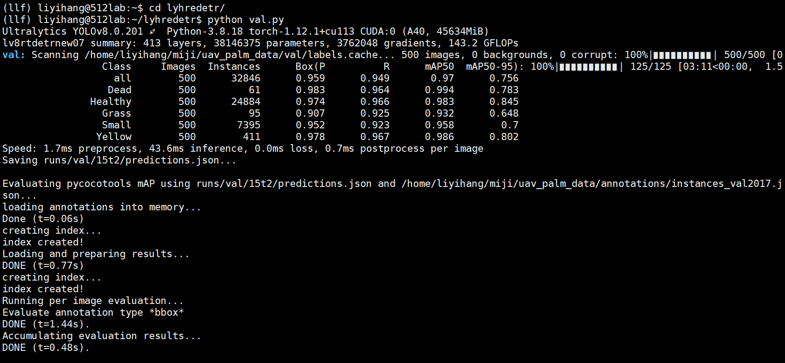

ph:

1. yolodetr
2. +LFPN
3. +c2f_DBB
4. +loss
5. zong

ph01

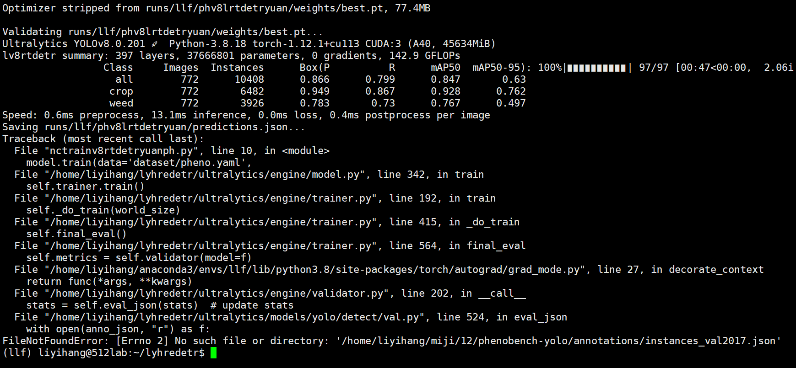

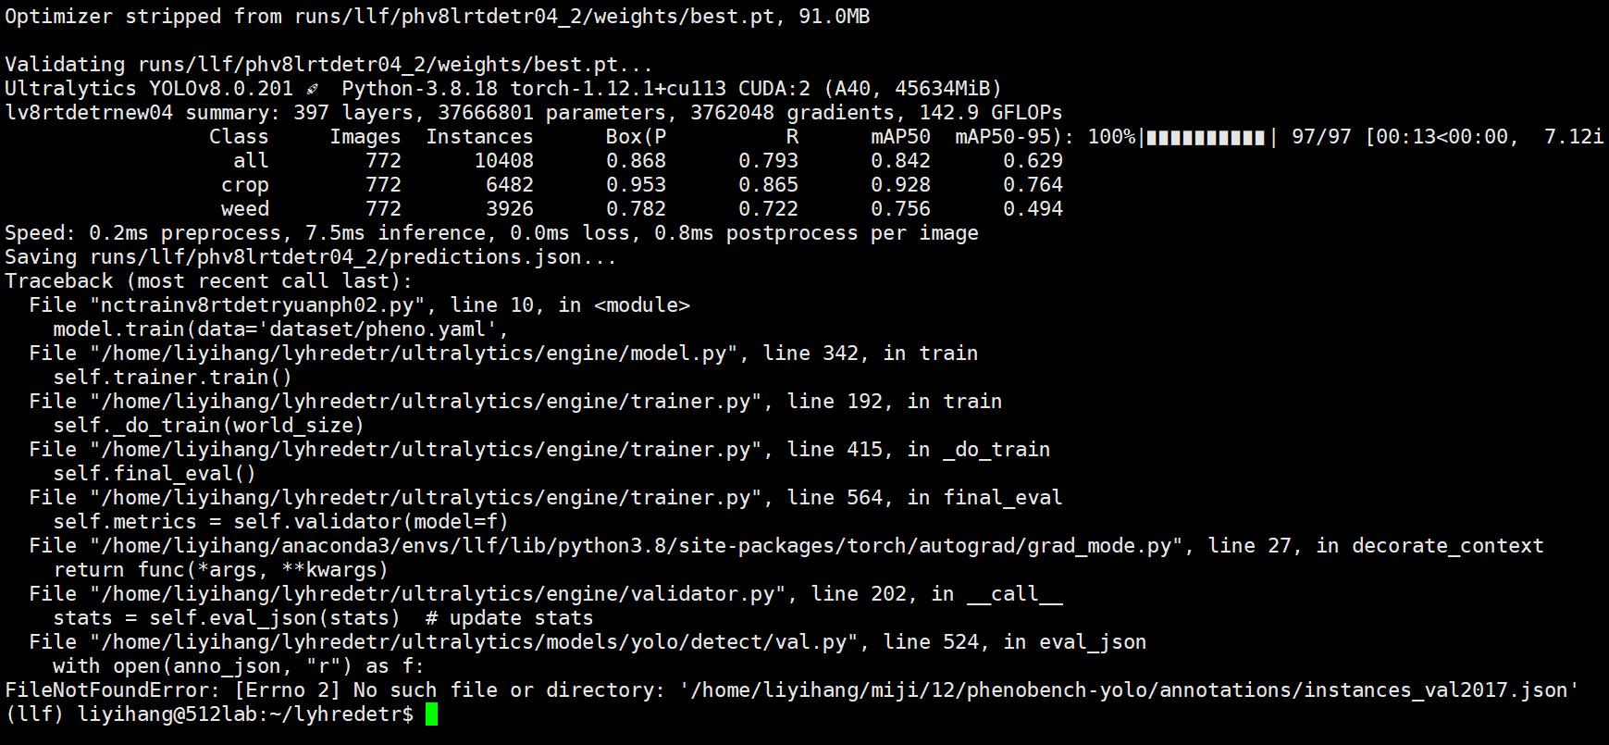

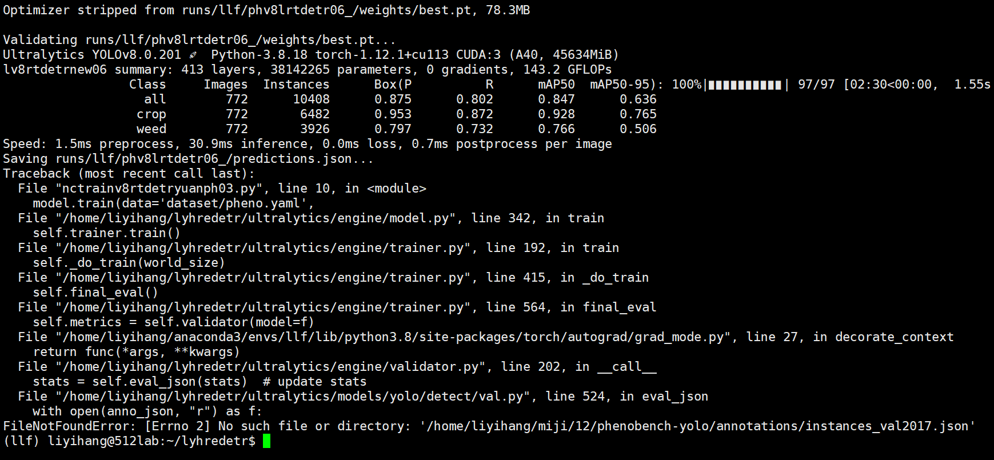

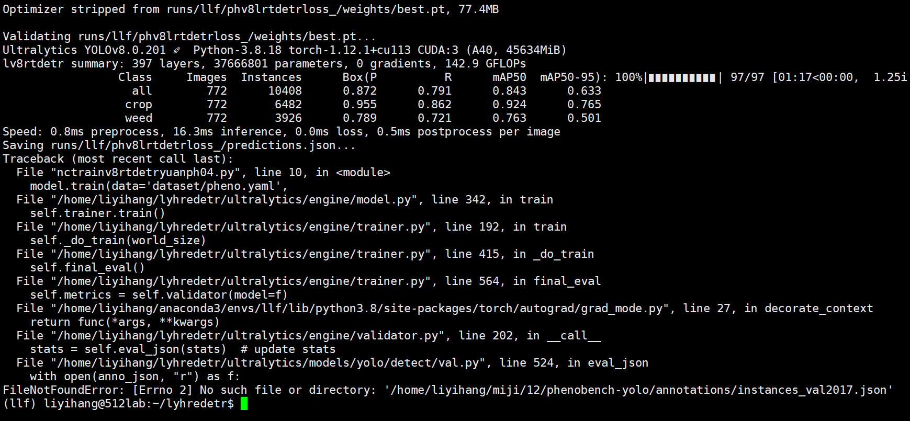

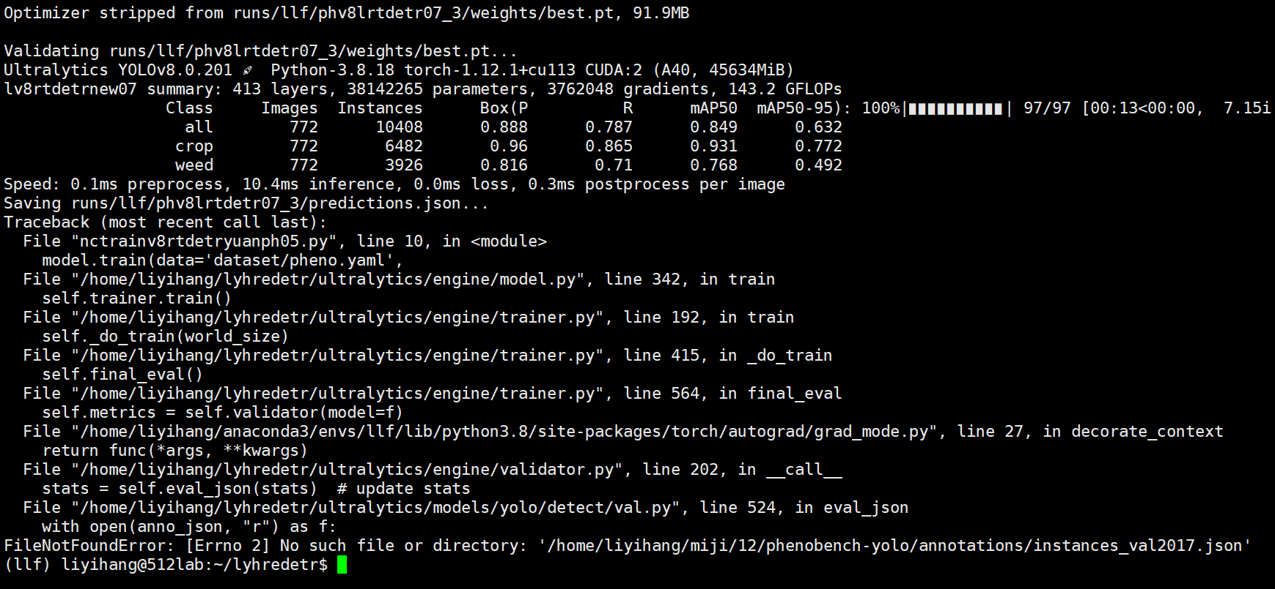

|  |  |  |  |  |  |  |  |
| --- | --- | --- | --- | --- | --- | --- | --- |
| **method** | **size** | **P** | **Q** | **AP50** | **mAP** | **Para** | **GFLOPS** |
| RTYO |  | 86.6 | 79.9 | 84.7 | 63 | 3767Wpara | 142.9 |
| RTYO+loss |  | 87.2 | 79.1 | 84.3 | 63.3 | 3767Wpara | 142.9 |
| RTYO+CFB |  | 86.8 | 79.3 | 84.2 | 62.9 | 3767Wpara | 142.9 |
| RTYO+LFPN |  | 87.5 | 80.2 | 84.7 | 63.6 | 3814W | 143.2 |
| ours |  | **88.8** | 78.7 | **84.9** | 63.2 | 3814W | 143.2 |
|  |  |  |  |  |  |  |  |
|  |  |  |  |  |  |  |  |

v5

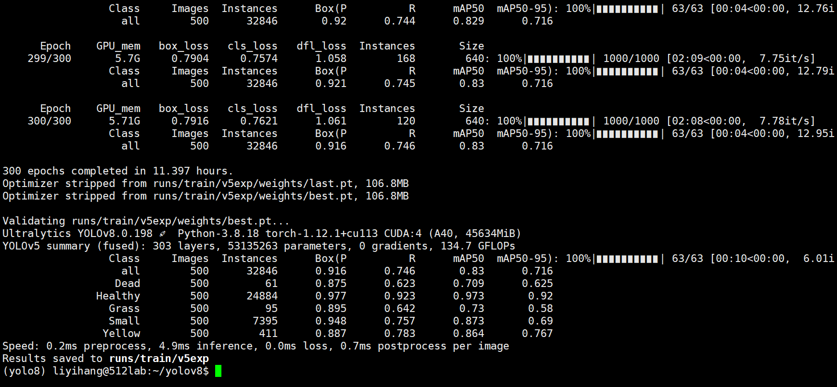

v3

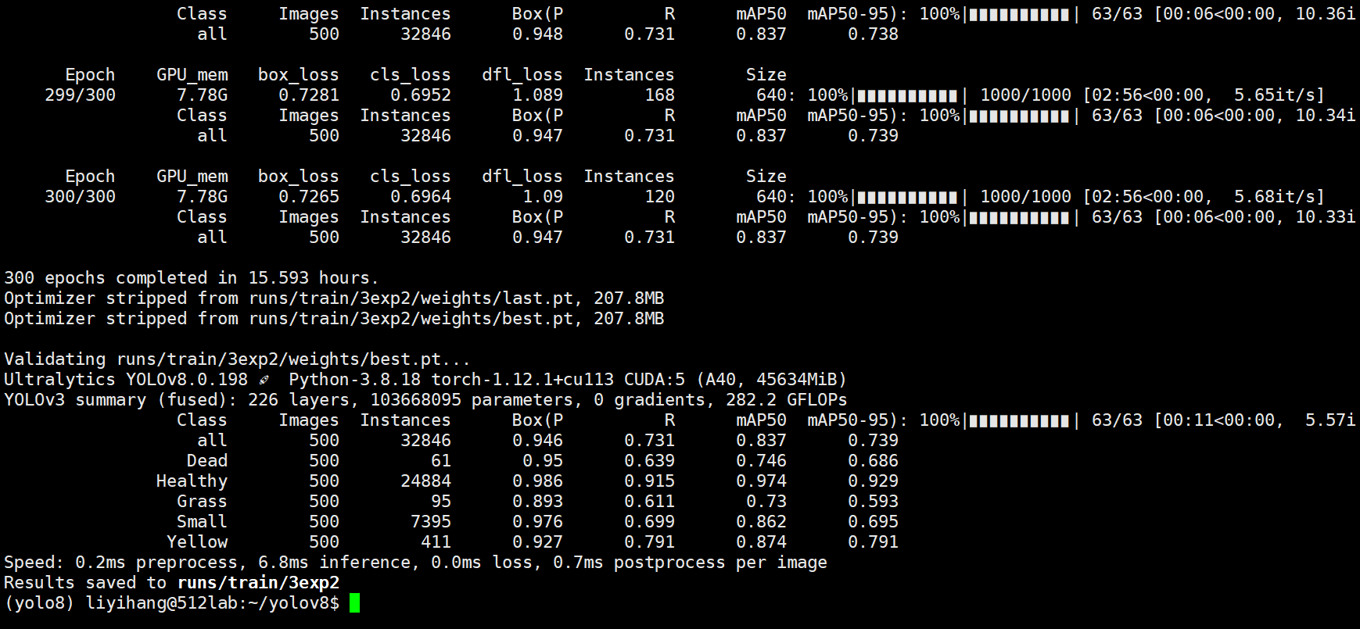

|  |  |  |  |  |  |  |  |
| --- | --- | --- | --- | --- | --- | --- | --- |
| **method** | **size** | **P** | **Q** | **AP50** | **mAP** | **Para** | **GFLOPS** |
| v3 |  | 86 | 80 | 85.9 | 67 | 3767Wpara | 142.9 |
| v5 |  | 87.6 | 81.2 | 87.1 | 68.6 | 3767Wpara | 142.9 |
| r-l |  | 87.7 | 79.2 | 84.4 | 62.6 | 3767Wpara | 142.9 |
| v8 |  | 88.3 | 79.9 | 86.7 | 68.6 | 3814W | 143.2 |
| ours |  | **88.8** | 79.9 | **84.9** | 63.2 | 3814W | 143.2 |
|  |  |  |  |  |  |  |  |
|  |  |  |  |  |  |  |  |

phv3

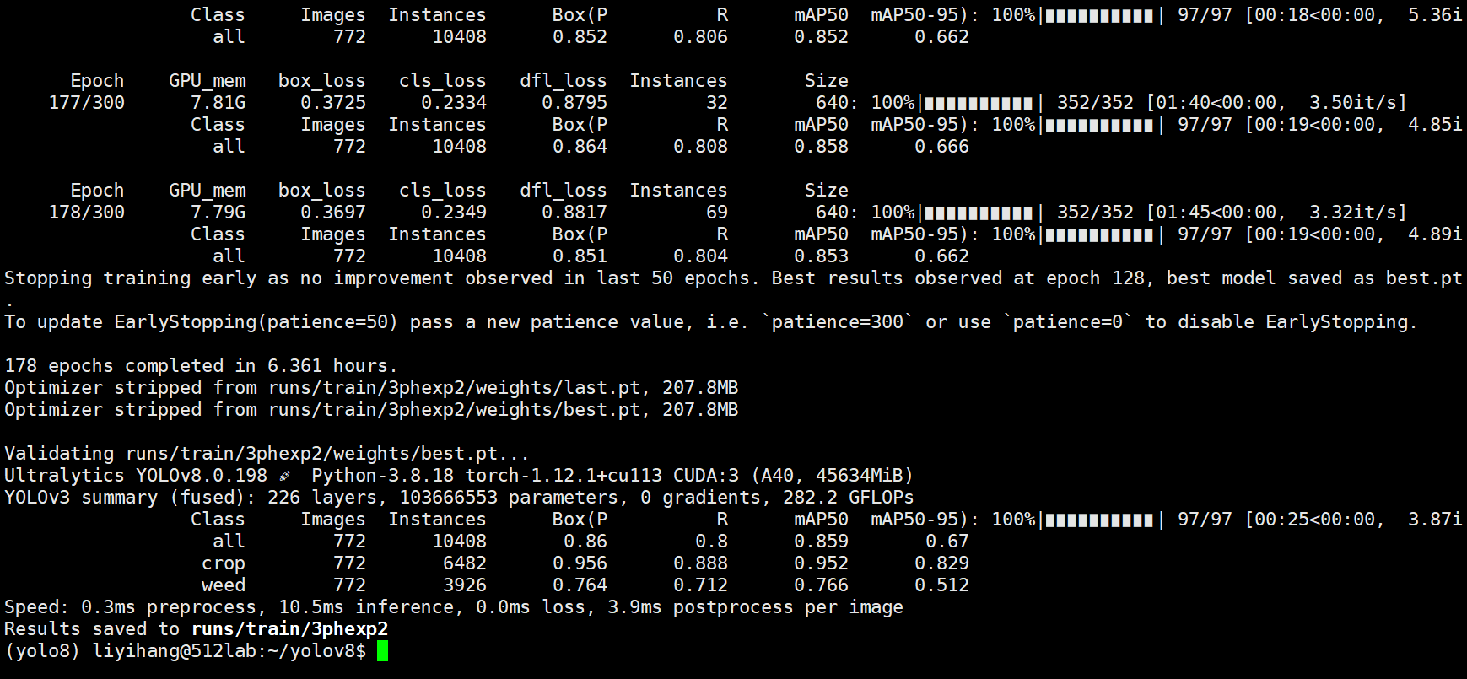

phv5

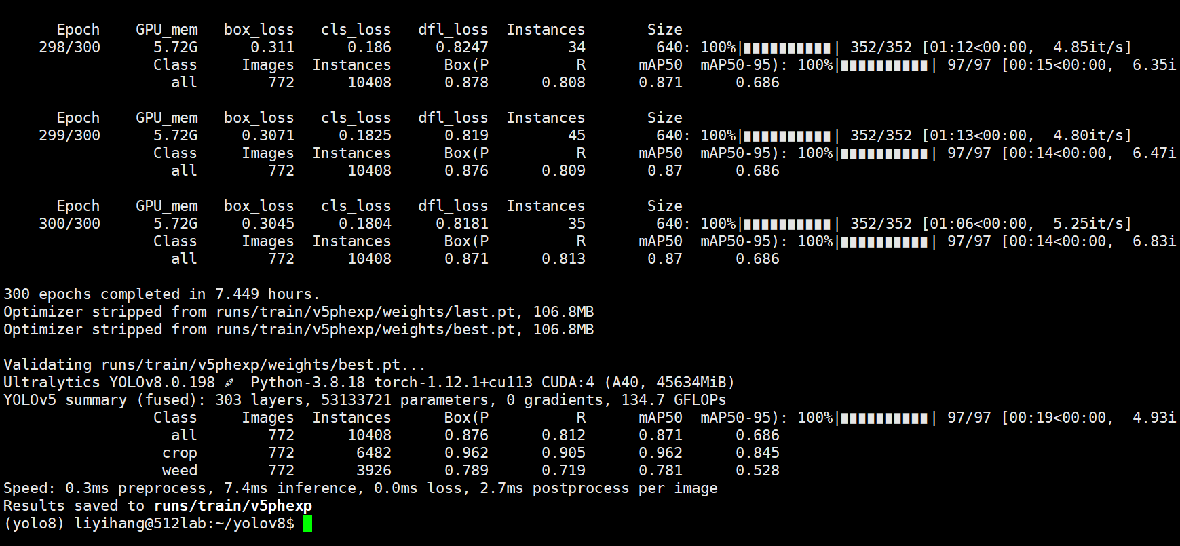

r-l

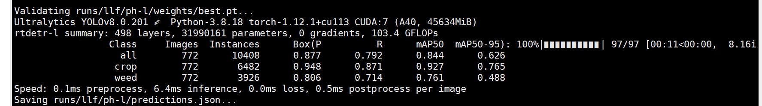

v8ph

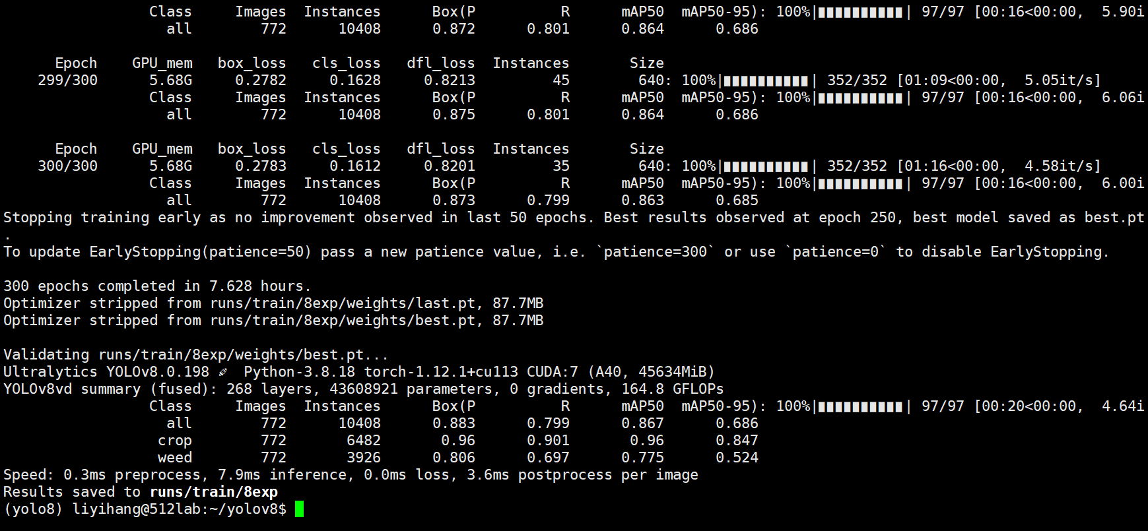

re

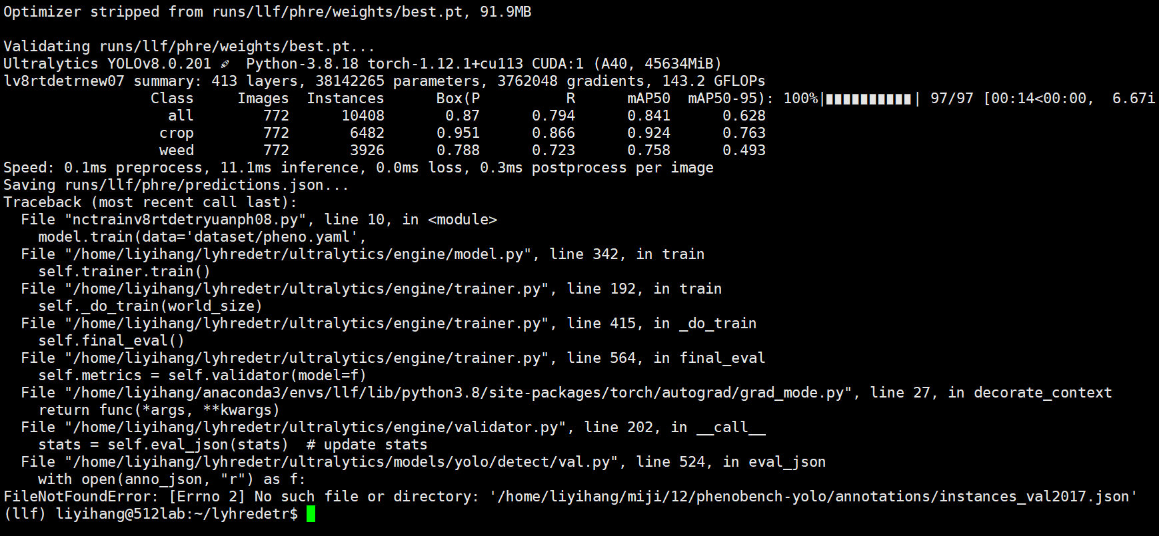

r50ph

